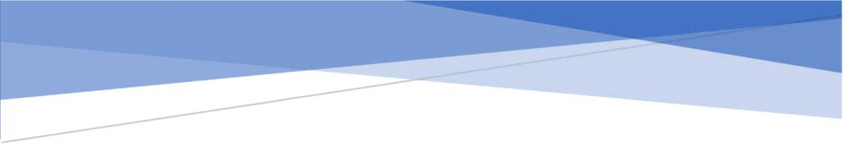**TAI LIEU ON THI Xtf LY ANH**

MATLAB App Designer

NOI DUNG THI HOC PHAN XU* LY ANH  
Xay dung App trong App Designer cua Matlab

**MUC LUC**

• •

1. Doc anh1
2. Chuyen doi anh2
3. Thao tac v&i anh mau RGB4
4. Xw ly diem8
5. Xw ly to chdc do15
6. Cacphep toan so hoc tren anh25
7. Loc lam min anh: Mean, Gaussian, Median, Order filter33
8. Phat hien bien + Loc lam net anh: Roberts, Prewitt, Sobel, Laplacian37
9. Xw ly hinh thai41
10. Sw dung Components trong Component Library de twang tac tot v&i ngw&i dung **43**
11. Doc anh

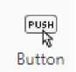Day la chnc nang ca ban ma moi app phai co.

Sn dung Button

trong Component Library de tao nut “Doc anh"

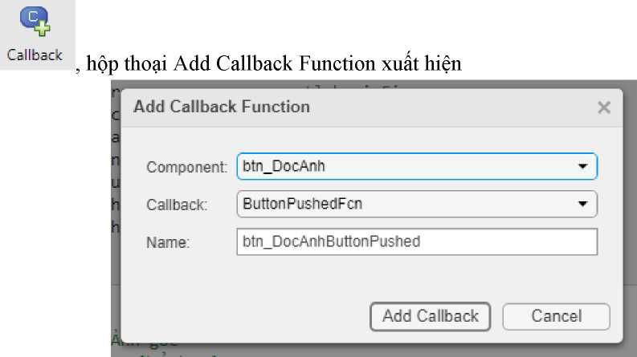Them cac thuoc tinh tai muc Property ^ Private Property (...be shared within the app only)

|  |  |
| --- | --- |
|  | **CHI Go To -** |
| **App Input Arguments** | Q, **Find ▼** |

**Property**

**Indent [>~1 4t>f| I?4 None**

**ent %** fa

n

**Private Property**

Private propert es store data to be shared w thin the app only

**Public Property**

Pubi c prcpert'es store data tc be shared inside ard outs de of the app

T

***~T~***

Gom co app.img la thuoc tinh giu anh doc vao va app.map gin map mau cua anh do.

properties (Access = private) **img % Anh goc map % Map anh goc**

end

Them sn kien Button Pushed (an nut) cho nut “Doc anh"

Chon

Chon “Add Callback" % Button pushed function: btn DocAnh

function btn DocAnhButtonPushed(app, event)

**[filename, path] = uigetfile({'*.png'; '*.jpg'; '*.tif'}, 'Chgn anh');**

**if ~isequal(filename, 0) && ~isequal(path, 0)**

**app.btn_DocAnh.Text = "Dgc anh khac"; file = strcat(path, filename);**

**[app.img, app.map] = imread(file);**

**imshow(app.img, app.map, 'Parent', app.axs_AnhGoc);**

**end**

end

1. Chuyen doi anh

**Xay dung giao dien;**

* Button: app.btnDocAnh
* Panel app.pnMain:

o Axes: app.axes AnhGoc, app.axes AnhChuyenDoi o Button: app.btn Chuyen

o Radio Button Group: rgTuyChon, gom cac Radio Button: app.rb AnhXam, app. rbNhiPhan

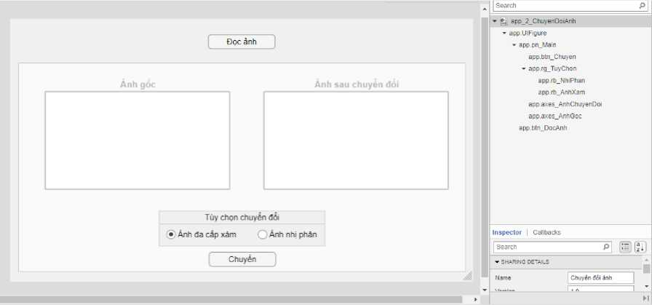

Bo check thuoc tich Enable cua doi tuong app.pn_Main trong phan Interactivity cua tab Inspector nham ngan ngudi dung thao tac tren du lieu rong.

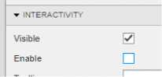

**Khdi tao thuoc tinh;**

properties (Access = private) **img % Anh goc map % Map anh goc colortype % Loai anh img_cd % Anh chuyen doi**

end

**Xay dung chuc nang cac thanh phan;**

Button Doc anh - SK: Button Pushed

% Button pushed function: btn DocAnh

function btn DocAnhButtonPushed(app, event)

**[filename, path] = uigetfile({'*.png'; '*.jpg'}, 'Chgn anh'); if ~isequal(filename, 0) && ~isequal(path, 0)**

**file = strcat(path, filename);**

**[app.img, app.map] = imread(file); app.colortype = imfinfo(file).ColorType; imshow(app.img, app.map, 'Parent', app.axes_AnhGoc); app.btn_DocAnh.Text = "Dgc anh khac"; app.pn_Main.Enable = "on";**

**end**

end

Button Chuyen - SK: Button Pushed

% Button pushed function: btn Chuyen

function btn ChuyenButtonPushed(app, event) if app.colortype == "truecolor"

**app.img_cd = rgb2gray(app.img); elseif app.colortype == "indexed"**

**app.img_cd = ind2gray(app.img, app.map);**

**else**

**app.img_cd = app.img;**

**end**

**if app.rg_TuyChon.SelectedObject == app.rb_NhiPhan app.img_cd = imbinarize(app.img_cd);**

**end**

**imshow(app.img_cd,'Parent',app.axes_AnhChuyenDoi);**

end

**Ket qua:**

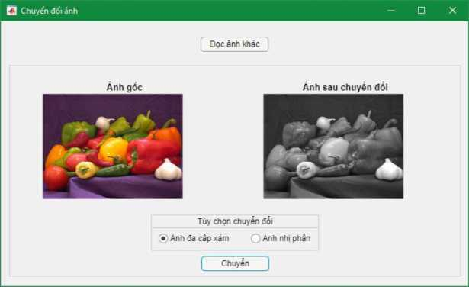

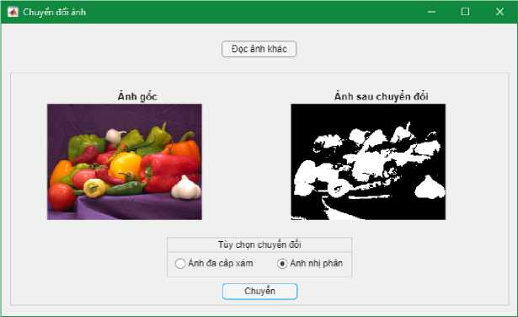

1. Thao tac v&i anh mau RGB

* Tach va hien thi anh tren 3 kenh mau RGB hoac CMY
* Tao lai anh RGB

(dung ham cat(3, anh R, anh G, anh B))

* Tao anh CMY

**Xay dung giao dien;**

* Button: app.btnDocAnh
* Panel app.pnAnhGoc:

o Axes: app.axes AnhGoc o Button: app.btn_Tach

o Radio Button Group: rg_HeMau, gom cac Radio Button: app.rb RGB, app.rb CMY

* Panel app.pnAnhTach:

o Axes: app.axes_KM1 (KM: Kenh mau), app.axes_KM2, app.axes_KM3

* Panel app.pnAnhHop:

o Axes: app.axes AnhHop o Button: app.btn Hop

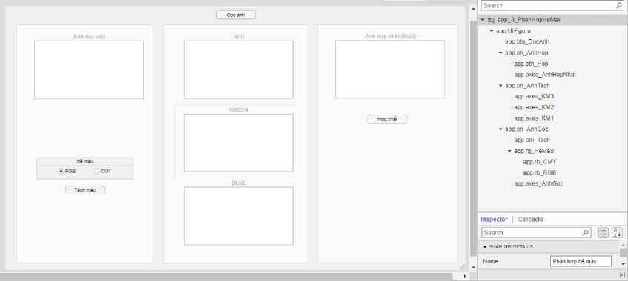

Bo check thuoc tich Enable cua cac doi tuong app.pn_AnhGoc, app.pn_AnhTach, app.pn_AnhHop trong phan Interactivity cua tab Inspector nham ngan ngubi dung thao tac tren du lieu rong.

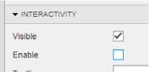

**Khdi tao thuoc tinh;**

properties (Access = private) **colortype % Loai anh img_rgb % Anh goc map % Map anh goc**

**R % Red**

**G % Green**

**B % Blue**

**img_rgb_cat % Anh sau khi gop 3 kenh mau RGB img_cmy % Anh bu cua anh goc**

**C % Cyan M % Magenta Y % Yellow**

end

**Xay dung chuc nang cac thanh phan:**

Button Doc anh - SK: Button Pushed

% Button pushed function: btn DocAnh

function btn DocAnhButtonPushed(app, event)

**[filename, path] = uigetfile({'*.png'; '*.jpg'}, 'Chgn anh'); if ~isequal(filename, 0) && ~isequal(path, 0)**

**file = strcat(path, filename); app.colortype = imfinfo(file).ColorType; if app.colortype ~= "truecolor"**

**uialert(app.UIFigure, 'Anh vua chpn khong phai anh RGB' , 'Loi'); return;**

**end**

**[app.img_rgb, app.map] = imread(file); app.img_cmy = imcomplement(app.img_rgb);**

**imshow(app.img_rgb, app.map, 'Parent', app.axes_AnhGoc); app.btn_DocAnh.Text = "Dgc anh khac"; app.pn_AnhGoc.Enable = "on";**

**end**

end

Button Tach - SK: Button Pushed

% Button pushed function: btn_Tach

function btn TachButtonPushed(app, event) **app.pn_AnhTach.Enable = "on"; app.pn_AnhHop.Enable = "on";**

**if app.rg_HeMau.SelectedObject == app.rb_RGB app.pn_AnhHop.Enable = "on";**

**app.axes_AnhGoc.Title.String = "Anh he RGB"; imshow(app.img_rgb, app.map, 'Parent', app.axes_AnhGoc); app.axes_KM1.Title.String = "RED"; app.axes_KM2.Title.String = "GREEN"; app.axes_KM3.Title.String = "BLUE";**

**%R**

**app.R = app.img_rgb; app.R(:, :, 2) = 0;**

**app.R(:, :, 3) = 0;**

**imshow(app.R, 'Parent', app.axes_KM1); app.R = app.img_rgb(:, :, 1);**

**%G**

**app.G = app.img_rgb; app.G(:, :, 1) = 0;**

**app.G(:, :, 3) = 0;**

**imshow(app.G, 'Parent', app.axes_KM2); app.G = app.img_rgb(:, :, 2);**

**%B**

**app.B = app.img_rgb; app.B(:, :, 1) = 0;**

**app.B(:, :, 2) = 0;**

**imshow(app.B, 'Parent', app.axes_KM3);**

**else**

**app.B = app.img_rgb(:, :, 3);**

**app.pn_AnhHop.Enable = "off"; cla(app.axes_AnhHopNhat);**

**app.axes_AnhGoc.Title.String = "Anh he CMY"; imshow(app.img_cmy, app.map, 'Parent', app.axes_KM1.Title.String = "CYAN"; app.axes_KM2.Title.String = "MAGENTA"; app.axes KM3.Title.String = "YELLOW";**

**app.axes AnhGoc);**

**%C**

**app.C = app.img_rgb; app.C(:, :, 1) = 0; imshow(app.C, 'Parent'**

**app.axes KM1);**

**%M**

**app.M = app.img_rgb; app.M(:, :, 2) = 0; imshow(app.M, 'Parent'**

**app.axes KM2);**

**%Y**

**app.Y = app.img_rgb; app.Y(:, :, 3) = 0; imshow(app.Y, 'Parent'**

**app.axes KM3)**

**end**

end

Button Hop nhat (chi RGB) - SK: Button Pushed

% Button pushed function: btn Hop

function btn HopButtonPushed(app, event)

**app.img_rgb_cat = cat(3, app.R, app.G, app.B); imshow(app.img_rgb_cat, 'Parent', app.axes_AnhHopNhat)**

end

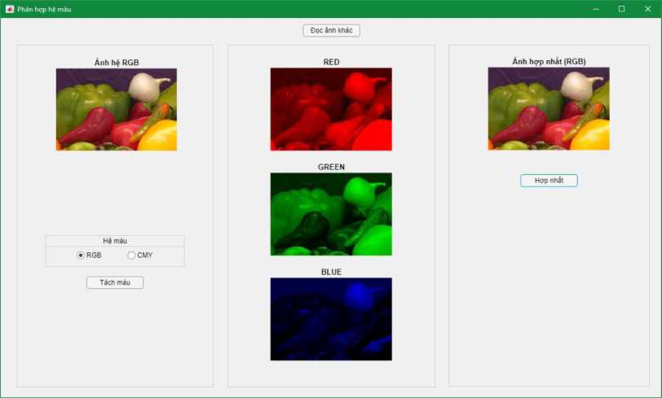

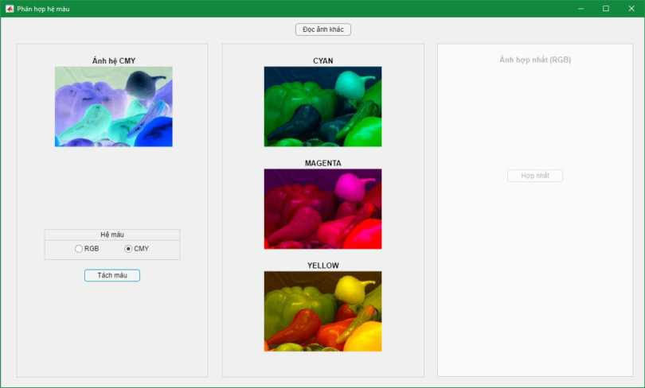

1. Xw ly diem

* Anh am ban
* Phan nguong dan hoac kep tren anh Anh am ban:

**Xay dung giao dien;**

* Axes: app.axs_AnhGoc, app.axsAnhAmBan
* Button: app.btnDocAnh

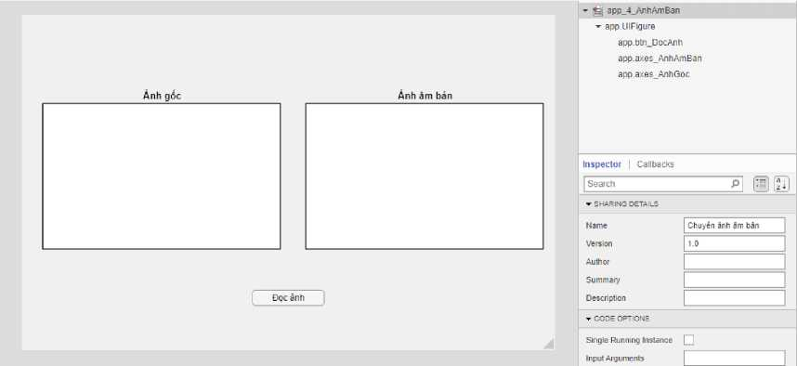

**Khai bao thuoc tinh;**

properties (Access = private) **img % Anh doc vao map % Map anh dpc vao**

end

**Xay dung chnc nang cac thanh phan;**

Button Doc anh - SK: Button Pushed

% Button pushed function: btn DocAnh

function btn DocAnhButtonPushed(app, event)

**[filename, path] = uigetfile({'*.png'; '*.jpg'}, 'Chpn anh'); if ~isequal(filename, 0) && ~isequal(path, 0)**

**file = strcat(path, filename);**

**[app.img, app.map] = imread(file);**

**imshow(app.img, app.map, 'Parent', app.axes_AnhGoc); imshow(imcomplement(app.img), app.map, 'Parent', app.axes_AnhAmBan); app.btn_DocAnh.Text = "Dpc anh khac";**

**end**

end

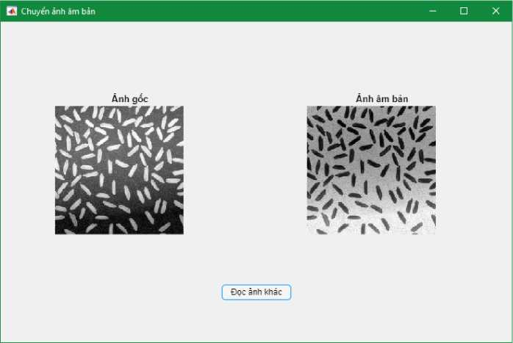

Phan ngudng dffn:

**Xay dung giao dien;**

* Axes: app.axs_AnhGoc, app.axs_AnhPhanNguong
* Button: app.btnDocAnh
* Slider: app.sldGiaTri
* Edit Field: app.efGiaTri

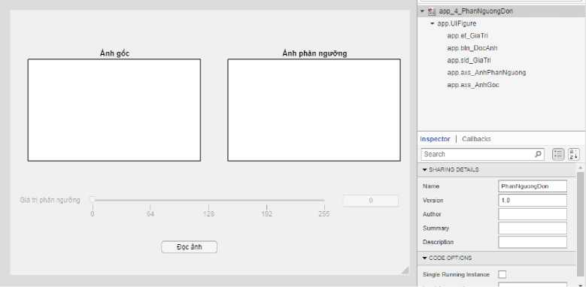

Bo check thuoc tich Enable cua cac doi tugng app.sld_GiaTri, app.sld_GiaTri trong phan

Interactivity cua tab Inspector nham ngan ngudi dung thao tac tren du lieu rong.

**Khfri tao thuoc tinh;**

properties (Access = private) **img % Anh goc img_gray % Anh xam map % Map anh goc info % Thong tin anh colortype % Loai anh**

end

**Xay dung chuc nang cac thanh phan;**

Button Doc anh - SK: Button Pushed

% Button pushed function: btn DocAnh

function btn DocAnhButtonPushed(app, event)

**[filename, path] = uigetfile({'*.png'; '*.jpg'; '*.tif'}, 'Chgn anh');**

**if ~isequal(filename, 0) && ~isequal(path, 0)**

**file = strcat(path, filename); app.info = imfinfo(file); if length(app.info) > 1**

**app.info = app.info(1);**

**end**

**Lmax = 2Aapp.info.BitDepth - 1; if Lmax == 1**

**uialert(app.UIFigure, 'Anh vua chgn la anh nhi phan', 'Chu y'); return;**

**end**

**[app.img, app.map] = imread(file); app.colortype = app.info.ColorType; if app.colortype == "truecolor"**

**app.img_gray = rgb2gray(app.img); elseif app.colortype == "indexed"**

**app.img_gray = ind2gray(app.img, app.map);**

**else**

**app.img_gray = app.img;**

**end**

**imshow(app.img_gray, app.map, 'Parent', app.axs_AnhGoc); imshow(app.img_gray > 128, app.map, 'Parent', app.axs_AnhPhanNguong);**

**app.btn_DocAnh.Text = "Dgc anh khac"; app.sld_GiaTri.Enable = "on"; app.ef_GiaTri.Enable = "on"; app.ef_GiaTri.Value = 128; app.sld_GiaTri.Value = 128;**

**end**

end

Slider Gia tri - SK: Value Changing

% Value changing function: sld GiaTri

function sld GiaTriValueChanging(app, event) changingValue = event.Value;

**app.ef_GiaTri.Value = round(changingValue, 0); imshow(app.img_gray > app.ef_GiaTri.Value, 'Parent', app.axs_AnhPhanNguong);**

end

Edit Field Gia tri - SK: Value Changed

% Value changed function: ef GiaTri

function ef GiaTriValueChanged(app, event) **value = app.ef_GiaTri.Value; app.ef_GiaTri.Value = round(value, 0); app.sld_GiaTri.Value = round(value, 0); imshow(app.img_gray > app.ef_GiaTri.Value, 'Parent', app.axs_AnhPhanNguong);**

end

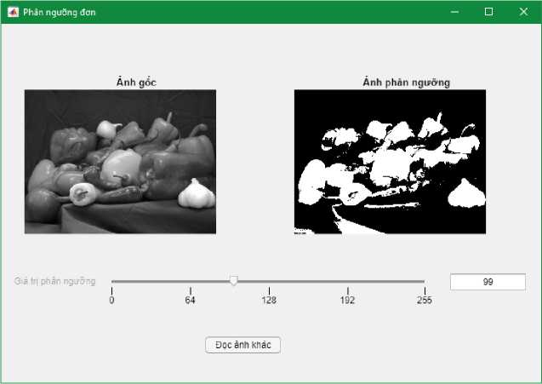

Phan ngudng kep:

**Xay dung giao dien;**

* Axes: app.axes_AnhGoc, app.axes_AnhPhanNguong
* Button: app.btnDocAnh
* Slider: app.sld NguongTrai, app.sld NguongPhai
* Edit Field: app.ef NguongTrai, app.ef NguongPhai

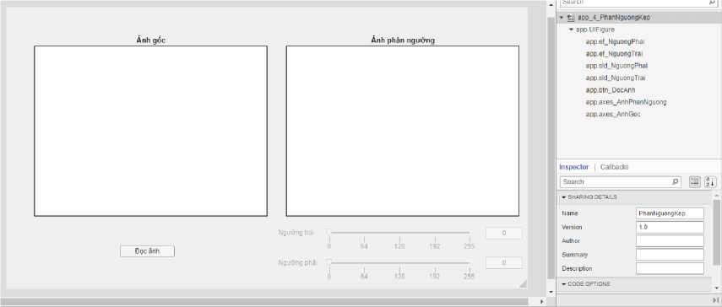

Bo check thuoc tich Enable cua cac doi tugng app.ef_NguongTrai, app.ef_NguongPhai, app.sld_NguongTrai, app.sld_NguongPhai trong phan Interactivity cua tab Inspector nham ngan ngudi dung thao tac tren du lieu rong.

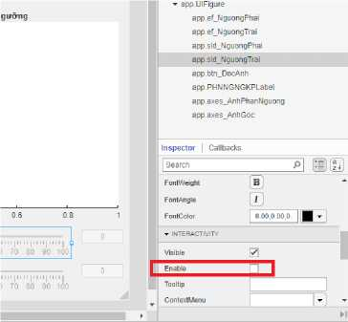

**Khai bao thuoc tfnh;**

properties (Access = private) **img % Anh goc map % Map anh goc info % Thong tin anh colortype % Loai mau anh**

**img_gray % Anh goc da chuyen thanh da cap xam**

end

**Khai bao chuc nang cac thanh phan;**

Button Doc anh - SK: Button pushed

% Button pushed function: btn DocAnh

function btn DocAnhButtonPushed(app, event)

**[filename, path] = uigetfile({'*.png'; '*.jpg'; '*.tif'}, 'Chgn anh');**

**if isequal(filename, 0) || isequal(path, 0)**

**return;**

**end**

**file = strcat(path, filename); app.info = imfinfo(file); if length(app.info) > 1**

**app.info = app.info(l);**

**end**

**Lmax = 2Aapp.info.BitDepth - 1; if Lmax == 1**

**uialert(app.UIFigure, 'Anh vua chgn la anh nhi phan', 'Chu y'); return;**

**end**

**[app.img, app.map] = imread(file); app.colortype = app.info.ColorType; if app.colortype == "truecolor"**

**app.img_gray = rgb2gray(app.img); elseif app.colortype == "indexed"**

**app.img_gray = ind2gray(app.img, app.map);**

**else**

**app.img_gray = app.img;**

**end**

**imshow(app.img_gray, app.map, 'Parent', app.axes_AnhGoc); imshow(app.img_gray > 64 & app.img_gray < 192, app.map, 'Parent', app.axes_AnhPhanNguong);**

**app.btn_DocAnh.Text = "Dgc anh khac"; app.sld_NguongTrai.Enable = "on"; app.sld_NguongPhai.Enable = "on"; app.ef_NguongTrai.Enable = "on";**

**app.ef_NguongPhai.Enable = "on"; app.sld_NguongTrai.Value = 64; app.sld_NguongPhai.Value = 192; app.ef_NguongTrai.Value = 64; app.ef_NguongPhai.Value = 192;**

end

Slider Nguang Trai - SK: Value Changing

% Value changing function: sld NguongTrai

function sld NguongTraiValueChanging(app, event) changingValue = event.Value;

**app.ef_NguongTrai.Value = round(changingValue, 0); if app.ef_NguongTrai.Value > app.ef_NguongPhai.Value app.ef_NguongPhai.Value = app.ef_NguongTrai.Value; app.sld_NguongPhai.Value = app.ef_NguongTrai.Value;**

**end**

**imshow(app.img_gray > app.ef_NguongTrai.Value & app.img_gray < app.ef_NguongPhai.Value, 'Parent', app.axes_AnhPhanNguong);**

end

Slider Nguang Phai - SK: Value Changing

% Value changing function: sld NguongPhai

function sld NguongPhaiValueChanging(app, event) changingValue = event.Value;

**app.ef_NguongPhai.Value = round(changingValue, 0); if app.ef_NguongPhai.Value < app.ef_NguongTrai.Value app.ef_NguongTrai.Value = app.ef_NguongPhai.Value; app.sld_NguongTrai.Value = app.ef_NguongPhai.Value;**

**end**

**imshow(app.img_gray > app.ef_NguongTrai.Value & app.img_gray < app.ef_NguongPhai.Value, 'Parent', app.axes_AnhPhanNguong);**

end

Edit Field Nguang Trai - SK: Value Changed

% Value changed function: ef_NguongTrai

function ef NguongTraiValueChanged(app, event) **value = app.ef_NguongTrai.Value; app.ef_NguongTrai.Value = round(value, 0); app.sld_NguongTrai.Value = round(value, 0); if app.ef_NguongTrai.Value > app.ef_NguongPhai.Value app.ef_NguongPhai.Value = app.ef_NguongTrai.Value; app.sld_NguongPhai.Value = app.ef_NguongTrai.Value;**

**end**

**imshow(app.img_gray > app.ef_NguongTrai.Value & app.img_gray < app.ef_NguongPhai.Value, 'Parent', app.axes_AnhPhanNguong);**

end

Edit Field Nguang Phai - SK: Value Changed

% Value changed function: ef NguongPhai

function ef NguongPhaiValueChanged(app, event) **value = app.ef_NguongPhai.Value; app.ef_NguongPhai.Value = round(value, 0); app.sld_NguongPhai.Value = round(value, 0); if app.ef_NguongPhai.Value < app.ef_NguongTrai.Value app.ef_NguongTrai.Value = app.ef_NguongPhai.Value; app.sld_NguongTrai.Value = app.ef_NguongPhai.Value;**

**end**

**imshow(app.img_gray > app.ef_NguongTrai.Value & app.img_gray < app.ef_NguongPhai.Value, 'Parent', app.axes_AnhPhanNguong);**

end

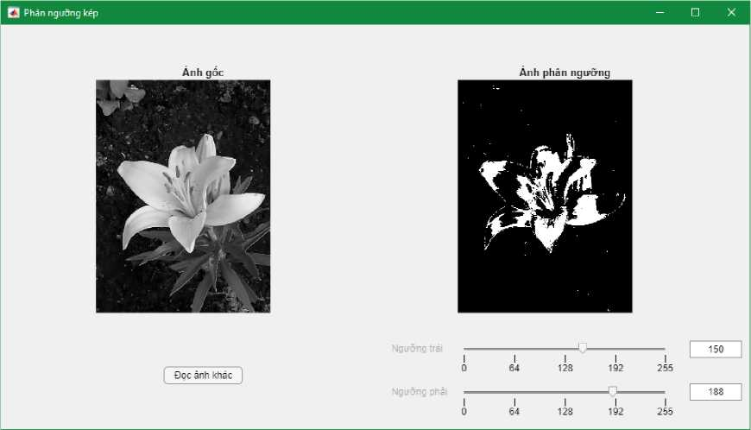

1. Xu ly to chuc do

* Hien thi to chnc do cua anh
* Traot, cang, bien doi tuyen tinh, can bang to chnc do

*(co the yen can tu viet ham hoac dung ham dung san)*

**Xay dung giao dien:**

Tab Group: app.tabTruot, app.tabCang, app.tabBDTT, app.tabCB • app.tabTruot (Traot)

o Axes: app.axsAnh_1, app.axs_Hist_1 o Button: app.bt_Doc1, app.bt_Reset_1 o Slider: app.sl_Truot_1 o Edit Field: app.ef_Truot_1

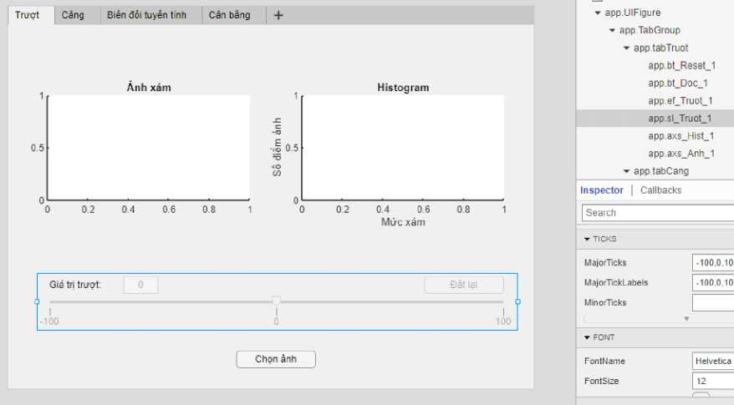• app.tabCang (Cang)

o Axes: app.axs_Anh2, app.axs_Hist_2 o Button: app.bt_Doc_2, app.bt_Reset_2 o Slider: app.sl_Cang_2 o Edit Field: app.ef_Cang_2

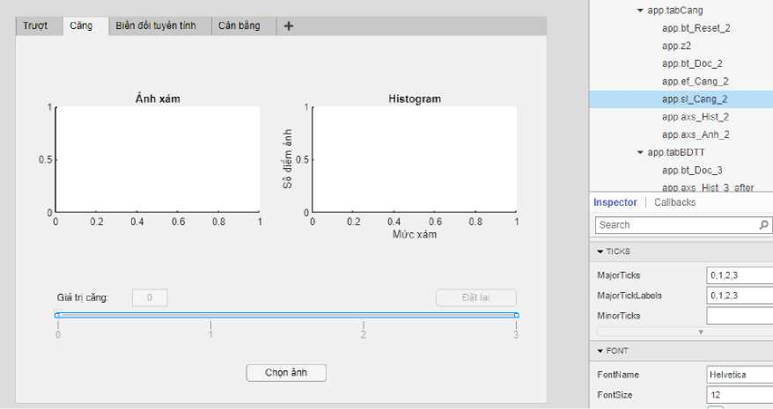app.tabCB (Can bang)

app.tabDBTT (Bien doi tuyen tinh)

o Axes: app.axs_Anh_3_before, app.axs_Anh_3_after, app.axs_Hist_3_before, app.axs_Hist_3_after o Button: app.bt_Doc 3

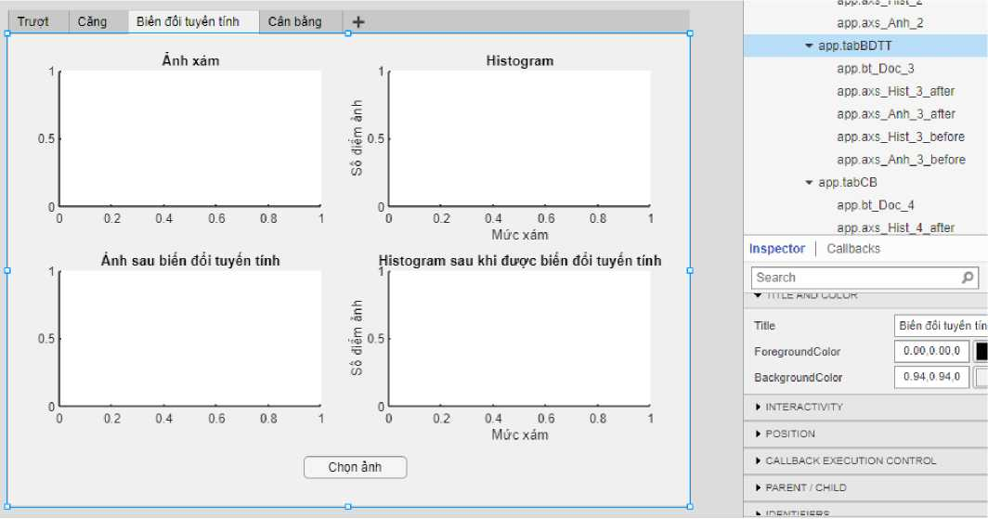

o Axes: app.axs_Anh_4_before, app.axs_Anh_4_after, app.axs_Hist_4_before, app.axs_Hist_4_after o Button: app.bt_Doc_4

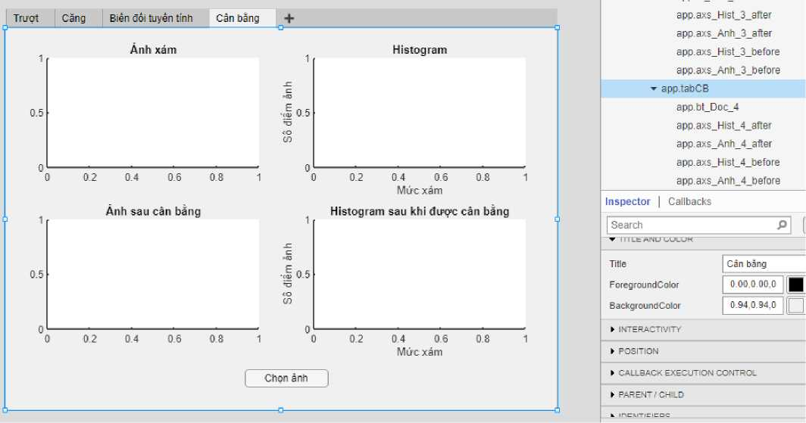

**Khai bao cac thuoc tinh va ham:**

Them ham: Function ^ Private Function

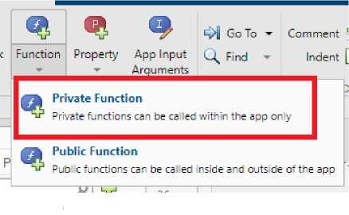properties (Access = private)

**% _1: thuoc tab Truot; _2: thuoc tab Cang; _3: thuoc tinh; _4: thuoc tab Can bang img_1 info_1 gray_1 map_1**

**tab Bien doi tuyen**

**colortype_1**

**Lmax_1**

**img_2**

**info_2**

**gray_2**

**map_2**

**colortype_2**

**Lmax_2**

**img_3**

**info_3**

**gray_3**

**map_3**

**colortype_3 Lmax_3 img_4 info_4 gray 4**

**map_4**

**colortype_4**

**Lmax_4**

end

methods (Access = private)

**function oimg = truotToChucDo(app)**

**[y, x] = size(app.gray_1); oimg = zeros(y, x); c = app.ef_Truot_1.Value; for i = 1 : y**

**for j = 1 : x**

**oimg(i, j) = app.gray_1(i, j) + c; if(oimg(i, j) > app.Lmax_1) oimg(i, j) = app.Lmax_1; elseif (oimg(i, j) < 0) oimg(i, j) = 0;**

**end**

**end**

**end**

**end**

**function oimg = cangToChucDo(app)**

**[y, x] = size(app.gray_2); oimg = zeros(y, x); c = app.ef_Cang_2.Value; for i = 1 : y**

**for j = 1 : x**

**oimg(i, j) = app.gray_2(i, j) * c; if(oimg(i, j) > app.Lmax_2) oimg(i, j) = app.Lmax_2; elseif (oimg(i, j) < 0) oimg(i, j) = 0;**

**end**

**end**

**end**

**end**

end

**Xay dung chuc nang cho cac thanh phan:**

• Tab Truot:

Button Doc anh - SK: Button Pushed

% Button pushed function: bt Doc 1

function bt Doc 1ButtonPushed(app, event) f = app.UIFigure;

**[filename, path] = uigetfile({'*.png'; '*.jpg'; '*.tif'}, 'Chgn anh');**

**if isequal(filename, 0) || isequal(path, 0)**

**uialert(f, 'Chua chgn anh', 'Loi dgc anh'); cla(app.axs_Anh_1);**

**else**

**% Enable cac thanh phan can thiet app.sl_Truot_1.Enable = true; app.ef_Truot_1.Enable = true; app.bt_Reset_1.Visible = true; app.bt_Doc_1.Text = 'Chgn anh khac';**

**% Dgc anh da chgn va xuat anh xam file = strcat(path, filename);**

**[app.img_1, app.map_1] = imread(file);**

**app.info_1 = imfinfo(file); app.colortype_1 = app.info_1.ColorType; if app.colortype_1 == "truecolor"**

**app.gray_1 = rgb2gray(app.img_1); elseif app.colortype_1 == "indexed"**

**app.gray_1 = ind2gray(app.img_1, app.map_1);**

**else**

**app.gray_1 = app.img_1;**

**end**

**imshow(app.gray_1, app.map_1, 'Parent', app.axs_Anh_1); if length(app.info_1) > 1**

**app.info_1 = app.info_1(1);**

**end**

**app.Lmax_1 = 2Aapp.info_1.BitDepth - 1; if app.Lmax_1 == 1**

**uialert(f, 'Anh vaa dugc chgn la anh nhi phan!', 'Luu y');**

**end**

**% Xuat hist goc app.axs_Hist_1.reset;**

**[numberofpixel, grayscale] = imhist(app.gray_1); bar(app.axs_Hist_1, grayscale, numberofpixel, 0.5, "stacked", "black");**

**app.ef_Truot_1.Value = 0; app.sl_Truot_1.Value = 0;**

**end**

end

Slider Gia tri truot - SK: Value Changing

% Value changing function: sl Truot 1

function sl Truot 1ValueChanging(app, event) changingValue = event.Value;

**% Dong bo du lieu vdi Edit field**

**app.ef_Truot_1.Value = round(changingValue, 0);**

**% Xu ly**

**oimg = app.truotToChucDo;**

**% Xuat thanh qua: anh output va hist cua no imshow(oimg , [], 'Parent', app.axs_Anh_1);**

**[onumberofpixel, ograyscale] = imhist(uint8(oimg)); bar(app.axs_Hist_1, ograyscale, onumberofpixel, 0.5, "stacked", "blue");**

end

Edit Field Gia tri truot - SK: Value Changed

% Value changed function: ef Truot 1

function ef Truot 1ValueChanged(app, event) value = app.ef_Truot_1.Value;

**% Dong bo du lieu vdi Slider app.sl_Truot_1.Value = value;**

**% Xu ly**

**oimg = app.truotToChucDo;**

**% Xuat thanh qua: anh output va hist cua no imshow(oimg , [], 'Parent', app.axs_Anh_1);**

**[onumberofpixel, ograyscale] = imhist(uint8(oimg)); bar(app.axs_Hist_1, ograyscale, onumberofpixel, 0.5, "stacked", "blue");**

end

Button Reset - SK: Button Pushed

% Button pushed function: bt Reset 1

function bt Reset 1ButtonPushed(app, event)

**imshow(app.gray_1, app.map_1, 'Parent', app.axs_Anh_1);**

**% Xuat hist goc app.axs_Hist_1.reset;**

**[numberofpixel, grayscale] = imhist(app.gray_1);**

**bar(app.axs_Hist_1, grayscale, numberofpixel, 0.5, "stacked", "black"); app.ef_Truot_1.Value = 0; app.sl_Truot_1.Value = 0;**

end

• Tab Cang:

Button Doc anh - SK: Button Pushed

% Button pushed function: bt Doc 2

function bt Doc 2ButtonPushed(app, event) f = app.UIFigure;

**[filename, path] = uigetfile({'*.png'; '*.jpg'; '*.tif'}, 'Chgn anh');**

**if isequal(filename, 0) || isequal(path, 0)**

**uialert(f, 'Chua chgn anh', 'Loi dgc anh'); cla(app.axs_Anh_2);**

**else**

**% Enable cac thanh phan can thiet app.sl_Cang_2.Enable = true; app.ef_Cang_2.Enable = true; app.bt_Reset_2.Visible = true; app.bt_Doc_2.Text = 'Chgn anh khac';**

**% Dgc anh da chgn va xuat anh xam file = strcat(path, filename);**

**[app.img_2, app.map_2] = imread(file); app.info_2 = imfinfo(file); app.colortype_2 = app.info_2.ColorType; if app.colortype_2 == "truecolor"**

**app.gray_2 = rgb2gray(app.img_2); elseif app.colortype_2 == "indexed"**

**app.gray_2 = ind2gray(app.img_2, app.map_2);**

**else**

**app.gray_2 = app.img_2;**

**end**

**imshow(app.gray_2, app.map_2, 'Parent', app.axs_Anh_2); if length(app.info_2) > 1**

**app.info_2 = app.info_2(1);**

**end**

**app.Lmax_2 = 2Aapp.info_2.BitDepth - 1; if app.Lmax_2 == 1**

**uialert(f, 'Anh vua dugc chgn la anh nhi phan!', 'Luu y');**

**end**

**% Xuat hist goc app.axs_Hist_2.reset;**

**[numberofpixel, grayscale] = imhist(app.gray_2);**

**bar(app.axs_Hist_2, grayscale, numberofpixel, 0.5, "stacked", "black");**

**app.ef_Cang_2.Value = 1; app.sl_Cang_2.Value = 1;**

**end**

end

Slider Gia tri cang - SK: Value Changing

% Value changing function: sl Cang 2

function sl Cang 2ValueChanging(app, event) changingValue = event.Value;

**% Dong bo du lieu vdi Edit field app.ef_Cang_2.Value = changingValue;**

**% Xu ly**

**oimg = app.cangToChucDo;**

**% Xuat thanh qua: anh output va hist cua no imshow(oimg , [], 'Parent', app.axs_Anh._2);**

**[onumberofpixel, ograyscale] = imhist(uint8(oimg)); bar(app.axs_Hist_2, ograyscale, onumberofpixel, 0.5, "stacked", "blue");**

end

Edit Field Gia tri cang - SK: Value Changed

% Value changed function: ef Cang 2

function ef Cang 2ValueChanged(app, event) value = app.ef_Cang_2.Value;

**% Dong bo du lieu vdi Slider app.sl_Cang_2.Value = value;**

**% Xu ly**

**oimg = app.cangToChucDo;**

**% Xuat thanh qua: anh output va hist cua no imshow(oimg , [], 'Parent', app.axs_Anh_2);**

**[onumberofpixel, ograyscale] = imhist(uint8(oimg)); bar(app.axs_Hist_2, ograyscale, onumberofpixel, 0.5, "stacked", "blue");**

end

Button Reset - SK: Button Pushed

% Button pushed function: bt Reset 2

function bt Reset 2ButtonPushed(app, event)

**imshow(app.gray_2, app.map_2, 'Parent', app.axs_Anh_2);**

**% Xuat hist goc app.axs_Hist_2.reset;**

**[numberofpixel, grayscale] = imhist(app.gray_2); bar(app.axs_Hist_2, grayscale, numberofpixel, 0.5, "stacked", "black");**

**app.ef_Cang_2.Value = 1; app.sl_Cang_2.Value = 1;**

end

• Tab Bien doi tuyen tinh:

Button Doc anh - SK: Button Pushed

% Button pushed function: bt Doc 3

function bt Doc 3ButtonPushed(app, event) f = app.UIFigure;

**[filename, path] = uigetfile({'*.png'; '*.jpg'; '*.tif'}, 'Chgn anh');**

**if isequal(filename, 0) || isequal(path, 0)**

**uialert(f, 'Chua chgn anh', 'Loi dgc anh'); cla(app.axs_Anh_3_before);**

**else**

**% Enable cac thanh phan can thiet app.bt_Doc_3.Text = 'Chgn anh khac';**

**% Dgc anh da chgn va xuat anh xam file = strcat(path, filename);**

**[app.img_3, app.map_3] = imread(file); app.info_3 = imfinfo(file); app.colortype_3 = app.info_3.ColorType; if app.colortype_3 == "truecolor"**

**app.gray_3 = rgb2gray(app.img_3); elseif app.colortype_3 == "indexed"**

**app.gray_3 = ind2gray(app.img_3, app.map_3);**

**else**

**app.gray_3 = app.img_3;**

**end**

**imshow(app.gray_3, app.map_3, 'Parent', app.axs_Anh_3_before);**

**if length(app.info_3) > 1**

**app.info_3 = app.info_3(1);**

**end**

**app.Lmax_3 = 2Aapp.info_3.BitDepth - 1; if app.Lmax_3 == 1**

**uialert(f, 'Anh vaa dugc chgn la anh nhi phan!', 'Luu y'); [numberofpixel, grayscale] = imhist(app.gray_3); bar(app.axs_Hist_3_before, grayscale, numberofpixel, 0.5, "stacked", "black"); cla(app.axs_Anh_3_after); cla(app.axs_Hist_3_after); return;**

**end**

**% Xuat hist goc va hist da xu ly**

**[numberofpixel, grayscale] = imhist(app.gray_3); bar(app.axs_Hist_3_before, grayscale, numberofpixel, 0.5, "stacked", "black"); gray_3_after = imadjust(app.gray_3);**

**imshow(gray_3_after, 'Parent', app.axs_Anh_3_after); [numberofpixel, grayscale] = imhist(gray_3_after); bar(app.axs_Hist_3_after, grayscale, numberofpixel, 0.5,**

**"stacked", "blue");**

**end**

end

• Tab Can bang:

Button Doc anh - SK: Button Pushed

% Button pushed function: bt Doc 4

function bt Doc 4ButtonPushed(app, event) f = app.UIFigure;

**[filename, path] = uigetfile({'*.png'; '*.jpg'; '*.tif'}, 'Chgn anh');**

**if isequal(filename, 0) || isequal(path, 0)**

**uialert(f, 'Chua chgn anh', 'Loi dgc anh');**

**cla(app.axs_Anh_4_before);**

**else**

**% Enable cac thanh phan can thiet app.bt_Doc_4.Text = 'Chpn anh khac';**

**% Dpc anh da chpn va xuat anh xam file = strcat(path, filename);**

**[app.img_4, app.map_4] = imread(file); app.info_4 = imfinfo(file); app.colortype_4 = app.info_4.ColorType; if app.colortype_4 == "truecolor"**

**app.gray_4 = rgb2gray(app.img_4); elseif app.colortype_4 == "indexed"**

**app.gray_4 = ind2gray(app.img_4, app.map_4);**

**else**

**app.gray_4 = app.img_4;**

**end**

**imshow(app.gray_4, app.map_4, 'Parent', app.axs_Anh_4_before); if length(app.info_4) > 1**

**app.info_4 = app.info_4(1);**

**end**

**app.Lmax_4 = 2Aapp.info_4.BitDepth - 1; if app.Lmax_4 == 1**

**uialert(f, 'Anh vaa dugc chpn la anh nhi phan!', 'Luu y'); [numberofpixel, grayscale] = imhist(app.gray_4); bar(app.axs_Hist_4_before, grayscale, numberofpixel, 0.5, "stacked", "black"); cla(app.axs_Anh_4_after); cla(app.axs_Hist_4_after); return;**

**end**

**% Xuat hist goc va hist da xu ly**

**[numberofpixel, grayscale] = imhist(app.gray_4); bar(app.axs_Hist_4_before, grayscale, numberofpixel, 0.5, "stacked", "black"); gray_4_after = histeq(app.gray_4);**

**imshow(gray_4_after, 'Parent', app.axs_Anh_4_after); [numberofpixel, grayscale] = imhist(gray_4_after); bar(app.axs_Hist_4_after, grayscale, numberofpixel, 0.5, "stacked", "blue");**

**end**

end

**Ket qua:**

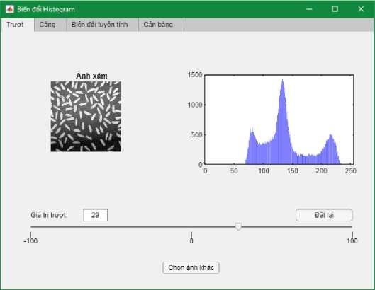

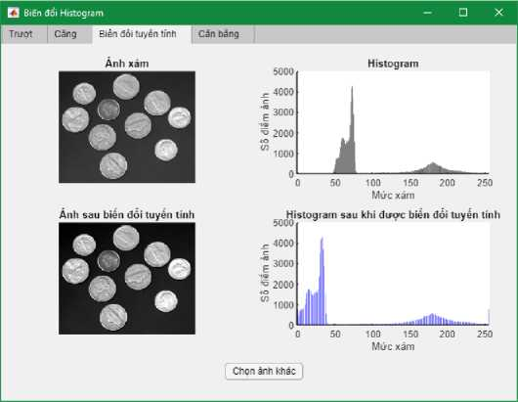

1. Cacphep toan so hoc tren anh

*(co the yen can tu viet ham hoac dung ham dung san)*

* Chuyen anh ve cung kmh thuoc

(chuyen thu cong hoac dung ham imresize dung kmh thuoc ymax, xmax)

* Cong anh
* Tru anh

Chuyen anh ve cung kfch thudc **Xay dung giao dien;**

* Panel app.pnAnhGoc:

o Axes: app.axs_Anh1, app.axs_Anh2 o Button: app.btn_DocAnh1, app.btn_DocAnh2 o Label: app.lb_Anh1, app.lb_Anh2 (Hien thi kich thuoc)

* Panel app.pnAnhKQ:

o Axes: app.axs_Anh1_KQ, app.axs_Anh2_KQ o Button: app.btn Chuyen o Label: app.lb_Anh1KQ, app.lbAnh2KQ

o Radio Button Group: app.rg PP (Phuong phap) gom co app.rb ScaleKeeping, app.rb ScaleMin, app. rb ScaleMax

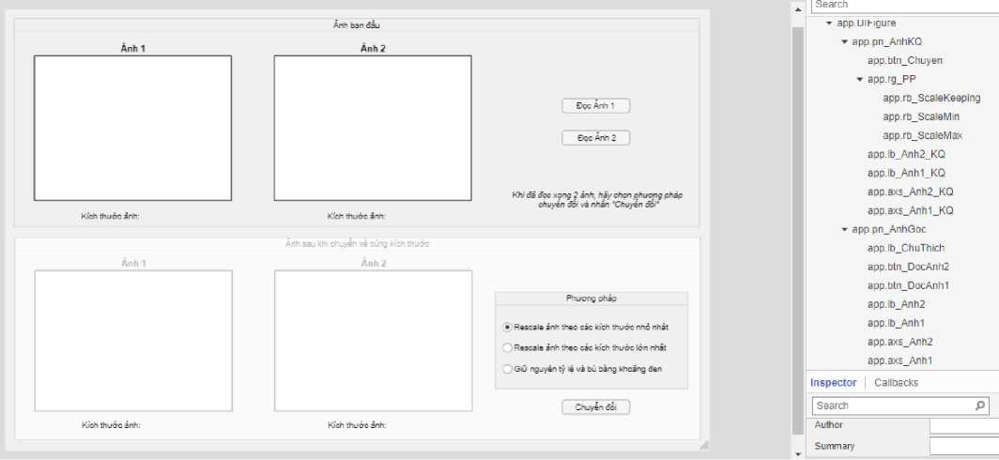

Bo check thuoc tich Enable cua doi tuong app.pn_AnhKQ trong phan Interactivity cua tab Inspector nham ngan nguoi dung thao tac tren du lieu rong.

**Khai bao cac thuoc tinh;**

properties (Access = private)

**AnhThuNhat_Set = false AnhThuHai_Set = false AnhCanResizel MapAnhCanResizel**

**yi**

**x1**

**AnhCanResize2**

**MapAnhCanResize2**

**y2**

**x2**

end

**Xay dung chuc nang cho cac thanh phan:**

Button Doc anh 1 - SK: Button Pushed

% Button pushed function: btn DocAnhl

function btn DocAnh1ButtonPushed(app, event) f = app.UIFigure;

**[filename, path] = uigetfile({'*.png'; '*.jpg'}, 'Chpn anh'); if isequal(filename, 0) || isequal(path, 0)**

**uialert(f, 'Chua chpn anh', 'Loi dpc anh'); app.AnhThuNhat_Set = false; cla(app.axs_Anh1);**

**else**

**app.AnhThuNhat_Set = true; file = strcat(path, filename);**

**[app.AnhCanResize1, app.MapAnhCanResize1] = imread(file); imshow(app.AnhCanResize1, app.MapAnhCanResize1, 'Parent', app.axs_Anh1);**

**app.y1 = size(app.AnhCanResize1, 1); app.x1 = size(app.AnhCanResize1, 2);**

**app.lb_Anh1.Text = "Kich thuoc anh: " + app.x1 + " x " + app.y1;**

**end**

**% Enable cho panel Chuyen doi**

**if app.AnhThuNhat_Set == true && app.AnhThuHai_Set == true app.pn_AnhKQ.Enable = "on";**

**else**

**app.pn_AnhKQ.Enable = "off";**

**end**

end

Button Doc anh 2 - SK: Button Pushed

% Button pushed function: btn DocAnh2

function btn DocAnh2ButtonPushed(app, event) f = app.UIFigure;

**[filename, path] = uigetfile({'*.png'; '*.jpg'; '*.tif'}, 'Chpn anh');**

**if isequal(filename, 0) || isequal(path, 0)**

**uialert(f, 'Chua chpn anh', 'Loi dpc anh'); app.AnhThuHai_Set = false; cla(app.axs_Anh2);**

**else**

**app.AnhThuHai_Set = true; file = strcat(path, filename);**

**[app.AnhCanResize2, app.MapAnhCanResize2] = imread(file); imshow(app.AnhCanResize2, app.MapAnhCanResize2, 'Parent', app.axs_Anh2);**

**app.y2 = size(app.AnhCanResize2, 1); app.x2 = size(app.AnhCanResize2, 2);**

**app.lb_Anh2.Text = "Kich thuoc anh: " + app.x2 + " x " + app.y2;**

**end**

**% Enable cho panel Chuyen doi**

**if app.AnhThuNhat_Set == true && app.AnhThuHai_Set == true app.pn_AnhKQ.Enable = "on";**

**else**

**app.pn_AnhKQ.Enable = "off";**

**end**

end

Button Chuyen doi - SK: Button Pushed

% Button pushed function: btn Chuyen

function btn ChuyenButtonPushed(app, event)

**if app.rg_PP.SelectedObject == app.rb_ScaleMax ymax = app.y1; xmax = app.x1; if app.y2 > ymax ymax = app.y2;**

**end**

**if app.x2 > xmax xmax = app.x2;**

**end**

**app.lb_Anh1_KQ.Text = "Kich thudc anh: " + xmax + " x " app.lb_Anh2_KQ.Text = "Kich thudc anh: " + xmax + " x "**

**+ ymax; + ymax;**

**+ ymin; + ymin;**

**+ ymax;**

**+ ymax;**

* **app.x1) ],**
* **app.x2)],**

1. **= imresize(app.AnhCanResize1, [ymax xmax]); imshow(OI1, 'Parent', app.axs_Anh1_KQ);**
2. **= imresize(app.AnhCanResize2, [ymax xmax]); imshow(OI2, 'Parent', app.axs_Anh2_KQ);**

**elseif app.rg_PP.SelectedObject == app.rb_ScaleMin ymin = app.y1; xmin = app.x1; if app.y2 < ymin ymin = app.y2;**

**end**

**if app.x2 < xmin xmin = app.x2;**

**end**

**app.lb_Anh1_KQ.Text = "Kich thudc anh: " + xmin + " x " app.lb_Anh2_KQ.Text = "Kich thudc anh: " + xmin + " x "**

1. **= imresize(app.AnhCanResize1, [ymin xmin]); imshow(OI1, 'Parent', app.axs_Anh1_KQ);**
2. **= imresize(app.AnhCanResize2, [ymin xmin]); imshow(OI2, 'Parent', app.axs_Anh2_KQ);**

**else**

**ymax = app.y1; xmax = app.x1; if app.y2 > ymax ymax = app.y2;**

**end**

**if app.x2 > xmax xmax = app.x2;**

**end**

**app.lb_Anh1_KQ.Text = "Kich thudc anh: " + xmax + " x " app.lb_Anh2_KQ.Text = "Kich thudc anh: " + xmax + " x "**

1. **= padarray(app.AnhCanResize1, [(ymax - app.y1) (xmax 0, 'post');**

**imshow(OI1, 'Parent', app.axs_Anh1_KQ);**

1. **= padarray(app.AnhCanResize2, [(ymax - app.y2) (xmax**

**0, 'post');**

**imshow(OI2, 'Parent', app.axs_Anh2_KQ);**

**end**

end

**Ket qua:**

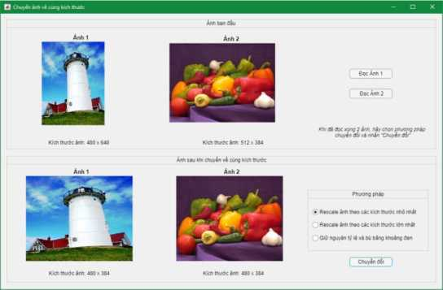

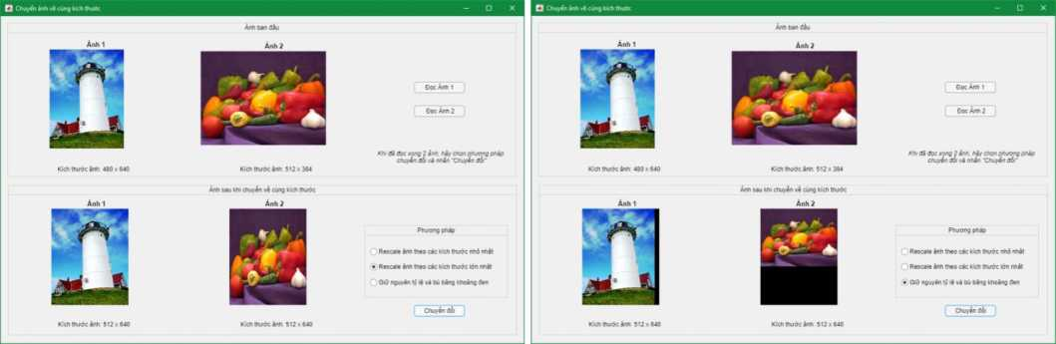

Cong, tru anh **Xay dung giao dien:**

* Toggle Button Group app.tbg_PhepToan gom co app.tb_Cong, app.tbTru
* Radio Button Group app.rg TuyChon gom co app.rb ToanHangAnh, app.rb ToanHangSo
* Button: app.btn_DocAnh1, app.btn_DocAnh2, btn TinhToan (dau =)
* Label: app.lb ToanTu (Hien thi truc quan dau + hoac -)
* Edit Field: app.ef_So
* Axes: app.axs_Anh1, app.axs_Anh2, app.axs AnhKQ

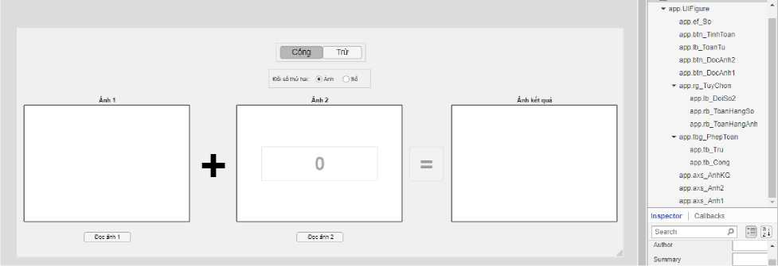

Edit Field app.ef_So nam phia tren Axes app.axs_Anh2 va bi uncheck thuoc tinh Enable, Button btn_TinhToan cung bi uncheck thuoc tinh Enable de tranh nguoi dung thao tac tren du lieu rong.

**Khai bao cac thuoc tfnh;**

properties (Access = private)

**A1_Set = false**

**A2_Set = false**

**AnhTrai**

**MapAnhTrai**

**AnhPhai**

**MapAnhPhai**

end

**Xav dung chuc nang cac thanh phan;**

Toggle Button Group Phep toan - SK: Selection Changed

% Selection changed function: tbg PhepToan

function tbg PhepToanSelectionChanged(app, event)

**selectedButton = app.tbg_PhepToan.SelectedObject; if selectedButton == app.tb_Cong app.axs_Anh2.Visible = "on"; app.btn_DocAnh2.Visible = "on"; app.rb_ToanHangAnh.Value = 1; app.ef_So.Visible = "off"; app.rg_TuyChon.Visible = "on"; app.lb_ToanTu.Text = "+"; app.ef_So.Value = 0; cla(app.axs_Anh2); app.btn_TinhToan.Enable = "off";**

**else**

**app.axs_Anh2.Visible = "on"; app.btn_DocAnh2.Visible = "on"; app.rb_ToanHangAnh.Value = 1; app.ef_So.Visible = "off"; app.rg_TuyChon.Visible = "on"; app.lb_ToanTu.Text = "-"; app.ef_So.Value = 0; cla(app.axs_Anh2); app.btn_TinhToan.Enable = "off";**

**end**

end

Radio Button Group Boi so thu 2 - SK: Selection Changed

% Selection changed function: rg TuyChon

function rg TuyChonSelectionChanged(app, event)

**selectedButton = app.rg_TuyChon.SelectedObject; if selectedButton == app.rb_ToanHangAnh app.axs_Anh2.Visible = "on"; cla(app.axs_Anh2); app.A2_Set = false; app.btn_TinhToan.Enable = "off"; app.btn_DocAnh2.Visible = "on"; app.ef_So.Visible = "off";**

**else**

**app.axs_Anh2.Visible = "off"; cla(app.axs_Anh2); app.btn_DocAnh2.Visible = "off"; app.ef_So.Visible = "on"; if app.A1_Set == true**

**app.btn_TinhToan.Enable = "on";**

**end**

**end**

end

Button Doc anh 1 - SK: Button Pushed

% Button pushed function: btn DocAnhl

function btn DocAnh1ButtonPushed(app, event) f = app.UIFigure;

**[filename, path] = uigetfile({'*.png'; '*.jpg'; '*.tif'}, 'Chgn anh');**

**if isequal(filename, 0) || isequal(path, 0)**

**uialert(f, 'Chua chgn anh', 'Loi dgc anh');**

**app.A1_Set = false;**

**cla(app.axs_Anh1);**

**else**

**file = strcat(path, filename);**

**Lmax = 2Aimfinfo(file).BitDepth - 1; if Lmax == 1**

**uialert(f, 'Anh vaa chgn la anh nhi phan!', 'Canh bao'); return;**

**end**

**app.A1_Set = true;**

**[app.AnhTrai, app.MapAnhTrai] = imread(file); colortype = imfinfo(file).ColorType; if colortype == "truecolor"**

**app.AnhTrai = rgb2gray(app.AnhTrai); elseif colortype == "indexed"**

**app.AnhTrai = ind2gray(app.AnhTrai, app.MapAnhTrai);**

**end**

**imshow(app.AnhTrai, app.MapAnhTrai, 'Parent', app.axs_Anh1); if app.rg_TuyChon.SelectedObject == app.rb_ToanHangSo || app.A2_Set == true app.btn_TinhToan.Enable = "on";**

**end**

**end**

end

Button Doc anh 2 - SK: Button Pushed

% Button pushed function: btn DocAnh2

function btn DocAnh2ButtonPushed(app, event) f = app.UIFigure;

**[filename, path] = uigetfile({'*.png'; '*.jpg'; '*.tif'}, 'Chpn anh');**

**if isequal(filename, 0) || isequal(path, 0)**

**uialert(f, 'Chua chpn anh', 'Loi dpc anh');**

**app.A2_Set = false;**

**cla(app.axs_Anh2);**

**else**

**file = strcat(path, filename);**

**Lmax = 2Aimfinfo(file).BitDepth - 1; if Lmax == 1**

**uialert(f, 'Anh vaa chpn la anh nhi phan!', 'Canh bao'); return;**

**end**

**app.A2_Set = true;**

**[app.AnhPhai, app.MapAnhPhai] = imread(file); colortype = imfinfo(file).ColorType; if colortype == "truecolor"**

**app.AnhPhai = rgb2 gray(app.AnhPhai);**

**elseif colortype == "indexed"**

**app.AnhPhai = ind2gray(app.AnhPhai, app.MapAnhPhai);**

**end**

**imshow(app.AnhPhai, app.MapAnhPhai, 'Parent', app.axs_Anh2);**

**end**

**% Enable cho nut =**

**if app.A1_Set == true && app.A2_Set == true app.btn_TinhToan.Enable = "on";**

**else**

**app.btn_TinhToan.Enable = "off";**

**end**

end

Button Tinh toan - SK: Button Pushed

% Button pushed function: btn TinhToan

function btn TinhToanButtonPushed(app, event)

**if app.tbg_PhepToan.SelectedObject == app.tb_Cong**

**if app.rg_TuyChon.SelectedObject == app.rb_ToanHangAnh ymax = size(app.AnhTrai, 1); xmax = size(app.AnhTrai, 2); if size(app.AnhPhai, 1) > ymax ymax = size(app.AnhPhai, 1);**

**end**

**if size(app.AnhPhai, 2) > xmax xmax = size(app.AnhPhai, 2);**

**end**

1. **= imresize(app.AnhTrai, [ymax xmax]);**
2. **= imresize(app.AnhPhai, [ymax xmax]);**
3. **= imadd(I1, I2, 'uint16');**

**imshow(I, [], 'Parent', app.axs_AnhKQ);**

**else**

**c = app.ef_So.Value;**

**KQ = imadd(app.AnhTrai, c);**

**imshow(KQ, [], 'Parent', app.axs_AnhKQ);**

**end**

**else**

**if app.rg_TuyChon.SelectedObject == app.rb_ToanHangAnh ymax = size(app.AnhTrai, 1); xmax = size(app.AnhTrai, 2); if size(app.AnhPhai, 1) > ymax ymax = size(app.AnhPhai, 1);**

**end**

**if size(app.AnhPhai, 2) > xmax xmax = size(app.AnhPhai, 2);**

**end**

1. **= imresize(app.AnhTrai, [ymax xmax]);**

**I2 = imresize(app.AnhPhai, [ymax xmax]);**

**I = imsubtract(I1, I2);**

**imshow(I, [], 'Parent', app.axs_AnhKQ);**

**else**

**c = app.ef_So.Value;**

**KQ = imsubtract(app.AnhTrai, c); imshow(KQ, [], 'Parent', app.axs_AnhKQ);**

**end**

end

**Ket qua:**

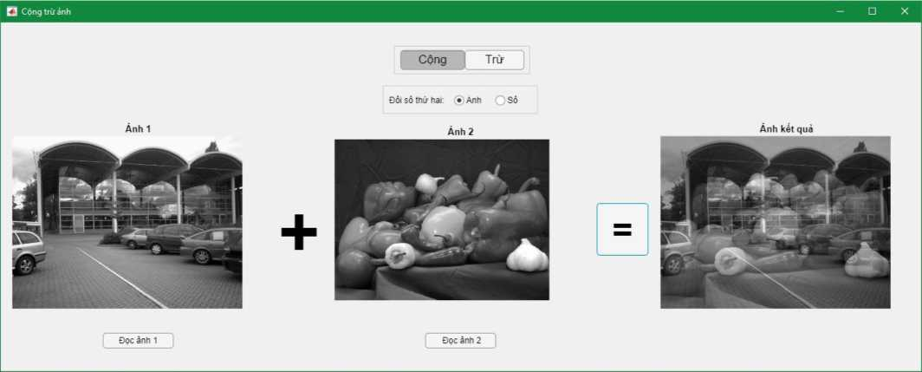

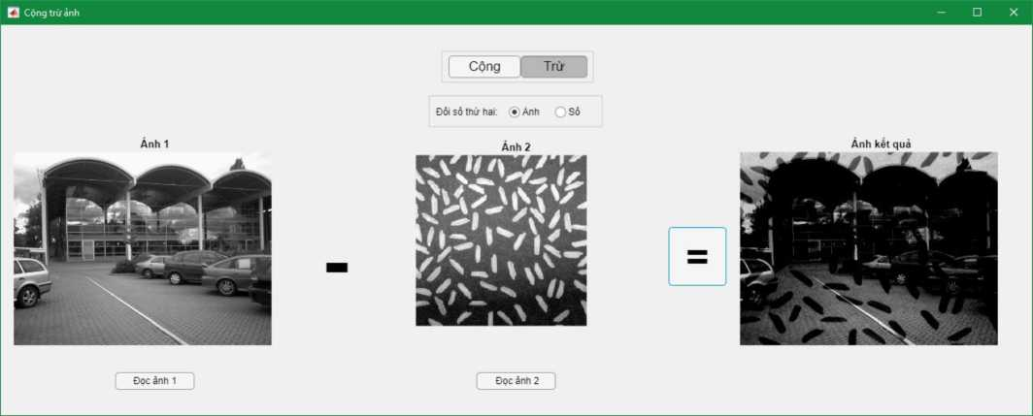

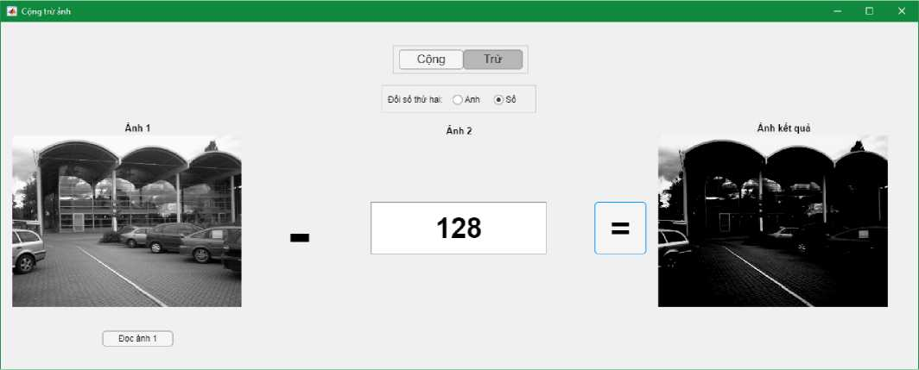

1. Loc lam min anh: Mean, Gaussian, Median, Order filter

*(sw dung cac ham loc anh dung san)*

**Xay dung giao dien;**

* Button: app.btnDocAnh
* Axes: app.axesAnhGoc
* Panel app.pnLamNhieu:

o Drop-down List: app.dd LoaiNhieu o Slider: app.sld Nhieu o Axes: app.axes AnhNhieu

* Panel app.pnLamMin:

o Drop-down List: app.dd PP LamMin, app.dd KichThuoc o Button: app.btn LamMin

o Axes: app.axes AnhLamMin

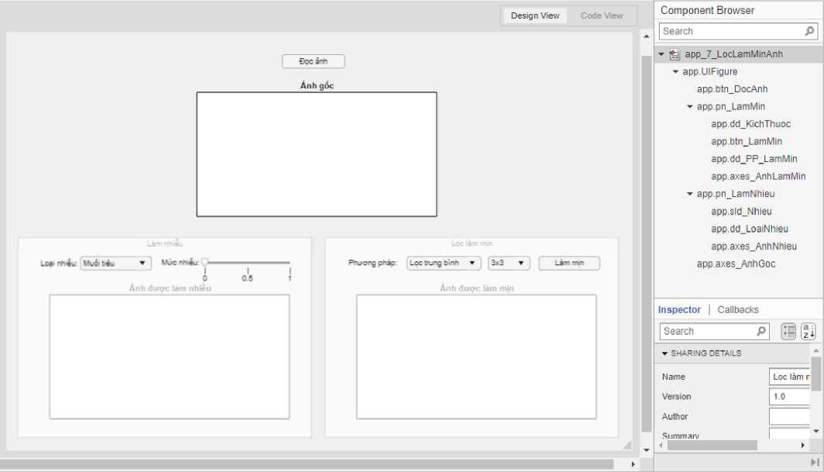Bo check Enable cho app.pn_LamNhieu va app.pn_LamMin de tranh viec ngudi dung thao tac du

lieu rong.

**Khai bao cac thuoc tinh;**

properties (Access = private) img map info

**colortype**

**img_gray**

**img_noise**

**img_lm**

end

**Xay dung chuc nang cho cac thanh phan;**

Button Doc anh - SK: Button Push

% Button pushed function: btn DocAnh

function btn DocAnhButtonPushed(app, event) f = app.UIFigure;

**[filename, path] = uigetfile({'*.png'; '*.jpg'}, 'Chpn anh'); if isequal(filename, 0) || isequal(path, 0)**

**uialert(f, "Chua chpn anh nao", "Loi dpc anh");**

**else**

**%**

**app.pn_LamMin.Enable = "off"; app.pn_LamNhieu.Enable = "on"; app.btn_DocAnh.Text = "Dpc anh khac"; app.sld_Nhieu.Value = 0; app.dd_KichThuoc.Value = "3x3"; app.dd_LoaiNhieu.Value = "Muoi tieu"; app.dd_PP_LamMin.Value = "Lpc trung binh";**

**%**

**file = strcat(path, filename); app.info = imfinfo(file);**

**Lmax = 2Aapp.info.BitDepth - 1; if Lmax == 1**

**uialert(f, "Anh vaa chpn la anh nhi phan", "Loi dpc anh"); return;**

**end**

**[app.img, app.map] = imread(file); app.colortype = app.info.ColorType; if app.colortype == "truecolor"**

**app.img_gray = rgb2gray(app.img); elseif app.colortype == "indexed"**

**app.img_gray = ind2gray(app.img, app.map);**

**else**

**app.img_gray = app.img;**

**end**

**imshow(app.img_gray, 'Parent', app.axes_AnhGoc); imshow(app.img_gray, 'Parent', app.axes_AnhNhieu); cla(app.axes_AnhLamMin);**

**end**

end

Slider Nhieu - SK: Value Changing

% Value changing function: sld Nhieu

function sld NhieuValueChanging(app, event) **changingValue = event.Value; if app.dd_LoaiNhieu.Value == "Muoi tieu"**

**app.img_noise = imnoise(app.img_gray, "salt & pepper", changingValue);**

**app.axes_AnhNhieu.Title.String = "Anh nhieu muoi tieu";**

**else**

**app.img_noise = imnoise(app.img_gray, "gaussian", changingValue); app.axes_AnhNhieu.Title.String = "Anh nhieu Gaussian";**

**end**

**imshow(app.img_noise, 'Parent', app.axes_AnhNhieu); imshow(app.img_noise, 'Parent', app.axes_AnhLamMin); app.pn_LamMin.Enable = "on";**

**app.axes_AnhLamMin.Title.String = "Anh can duoc lam min";**

end

Button Lam min - SK: Button Pushed

% Button pushed function: btn LamMin

function btn LamMinButtonPushed(app, event)

**i = app.img_noise;**

**if app.dd_PP_LamMin.Value == "Lpc trung binh" if app.dd_KichThuoc.Value == "3x3"**

**bl = fspecial("average", [3, 3]); elseif app.dd_KichThuoc.Value == "5x5" bl = fspecial("average", [5, 5]); elseif app.dd_KichThuoc.Value == "7x7" bl = fspecial("average", [7, 7]); elseif app.dd_KichThuoc.Value == "11x11" bl = fspecial("average", [11, 11]);**

**end**

**app.img_lm = filter2(bl, i);**

**imshow(app.img_lm/255, 'Parent', app.axes_AnhLamMin); elseif app.dd_PP_LamMin.Value == "Lpc trung vi" if app.dd_KichThuoc.Value == "3x3"**

**app.img_lm = medfilt2(i, [3, 3]); elseif app.dd_KichThuoc.Value == "5x5" app.img_lm = medfilt2(i, [5, 5]); elseif app.dd_KichThuoc.Value == "7x7" app.img_lm = medfilt2(i, [7, 7]); elseif app.dd_KichThuoc.Value == "11x11" app.img_lm = medfilt2(i, [11, 11]);**

**end**

**imshow(app.img_lm, 'Parent', app.axes_AnhLamMin); elseif app.dd_PP_LamMin.Value == "Lpc Gaussian" if app.dd_KichThuoc.Value == "0.5"**

**app.img_lm = imgaussfilt(i, 0.5); elseif app.dd_KichThuoc.Value == "1" app.img_lm = imgaussfilt(i, 1); elseif app.dd_KichThuoc.Value == "2" app.img_lm = imgaussfilt(i, 2); elseif app.dd_KichThuoc.Value == "4" app.img_lm = imgaussfilt(i, 4); elseif app.dd_KichThuoc.Value == "8" app.img_lm = imgaussfilt(i, 8);**

**end**

**imshow(app.img_lm, 'Parent', app.axes_AnhLamMin); elseif app.dd_PP_LamMin.Value == "Lpc Max" if app.dd_KichThuoc.Value == "3x3"**

**app.img_lm = ordfilt2(i, 9, ones(3, 3)); elseif app.dd_KichThuoc.Value == "5x5"**

**app.img_lm = ordfilt2(i, 25, ones(5, 5)); elseif app.dd_KichThuoc.Value == "7x7"**

**app.img_lm = ordfilt2(i, 49, ones(7, 7)); elseif app.dd_KichThuoc.Value == "11x11"**

**app.img_lm = ordfilt2(i, 121, ones(11, 11));**

**end**

**imshow(app.img_lm, 'Parent', app.axes_AnhLamMin); elseif app.dd_PP_LamMin.Value == "Lpc Min" if app.dd_KichThuoc.Value == "3x3"**

**app.img_lm = ordfilt2(i, 1, ones(3, 3)); elseif app.dd_KichThuoc.Value == "5x5"**

**app.img_lm = ordfilt2(i, 1, ones(5, 5)); elseif app.dd_KichThuoc.Value == "7x7"**

**app.img_lm = ordfilt2(i, 1, ones(7, 7)); elseif app.dd_KichThuoc.Value == "11x11"**

**app.img_lm = ordfilt2(i, 1, ones(11, 11));**

**imshow(app.img_lm, 'Parent', app.axes_AnhLamMin);**

**end**

**app.axes_AnhLamMin.Title.String = "Anh da duoc lam min";**

end

Drop-down List Phnong phap lam min - SK: Value Changed

% Value changed function: dd PP LamMin

function dd PP LamMinValueChanged(app, event) **value = app.dd_PP_LamMin.Value; if value == "Lpc Gaussian"**

**app.dd_KichThuoc.Items = ["0.5", "1", "2", "4", "8"];**

**else**

**app.dd_KichThuoc.Items = ["3x3", "5x5", "7x7", "11x11"];**

**end**

end

**Ket qua:**

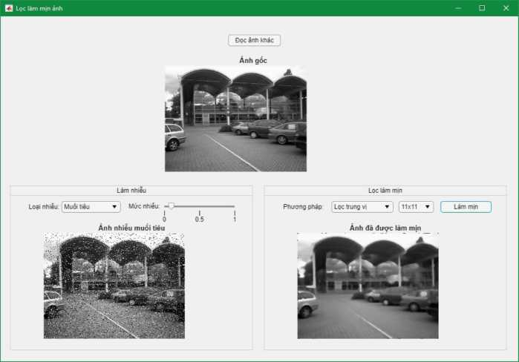

1. Phat hien bien + Loc lam net anh: Roberts, Prewitt, Sobel, Laplacian

*(chi su dung cac ham loc anh dung san)*

* Hien thi cac ket qua trung gian (anh bien ngang, bien doc) neu co
* Tuy bien bo loc Laplacian voi cac ban mo rong Xay dung giao dien;
* Button: app.btnDocAnh
* Panel app.pn_Main:

o Axes: app.axes AnhGoc, app.axes BienAnh, app.axes AnhNet o Drop-down List: app.dd ToanTu TachBien, app.dd LoaiBien, app.ddTuyChonLaplacian o Button: app.btn TachBien, app.btn LamNet

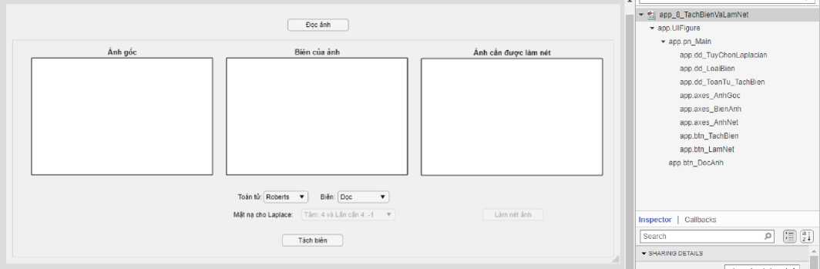

Bo check thuoc tinh Enable cua app.pn_Main de tranh viec ngndi dung thao tac dn lieu rong. Khai bao cac thuoc tinh;

properties (Access = private) img map info

**colortype**

**img_gray**

**img_edge**

**img_ln**

**% Roberts**

**Gx_Rb = [0, 1; -1, 0;];**

**Gy_Rb = [1, 0; 0, -1;];**

**% Prewitt**

**Gx_Prw = [-1, 0, 1; -1, 0, 1; -1, 0, 1;]; Gy_Prw = [-1, -1, -1; 0, 0, 0; 1, 1, 1;];**

**% Sobel**

**Gx_Sb = [-1, 0, 1; -2, 0, 2; -1, 0, 1;]; Gy_Sb = [-1, -2, -1; 0, 0, 0; 1, 2, 1;];**

**% Laplace**

**L_4 = [0, -1, 0; -1, 4, -1; 0, -1, 0;];**

**L_8 = [-1, -1, -1; -1, 8, -1; -1, -1, -1;];**

**Xay dung chuc nang cho cac thanh phan:**

Button Doc anh - SK: Button Pushed

% Button pushed function: btn DocAnh

function btn DocAnhButtonPushed(app, event) f = app.UIFigure;

**[filename, path] = uigetfile({'*.png'; '*.jpg'}, 'Chpn anh') if isequal(filename, 0) || isequal(path, 0)**

**uialert(f, "Chua chpn anh nao", "Loi dpc anh");**

**else**

**%**

**app.pn_Main.Enable = "on"; app.btn_DocAnh.Text = "Dpc anh khac";**

**app.dd_LoaiBien.Items = ["Dpc", "Ngang", "Toan bien"]; app.dd_LoaiBien.Value = "Dpc"; app.dd_ToanTu_TachBien.Value = "Roberts"; app.dd_TuyChonLaplacian.Enable = "off";**

**app.axes_AnhNet.Title.String = "Anh can dupc lam net";**

**%**

**file = strcat(path, filename); app.info = imfinfo(file);**

**Lmax = 2Aapp.info.BitDepth - 1; if Lmax == 1**

**uialert(f, "Anh vaa chpn la anh nhi phan", "Luu y"); return;**

**end**

**[app.img, app.map] = imread(file); app.colortype = app.info.ColorType; if app.colortype == "truecolor"**

**app.img_gray = rgb2gray(app.img); elseif app.colortype == "indexed"**

**app.img_gray = ind2gray(app.img, app.map);**

**else**

**app.img_gray = app.img;**

**end**

**imshow(app.img_gray, 'Parent', imshow(app.img_gray, 'Parent', cla(app.axes_BienAnh);**

**app.axes_AnhNet); app.axes AnhGoc);**

**end**

end

Button Tach bien - SK: Button Pushed

% Button pushed function: btn TachBien function btn TachBienButtonPushed(app, i = app.img gray;

event)

**if app.dd_ToanTu_TachBien.Value == "Roberts"**

**% Tach bien Robert**

**edge_x = filter2(app.Gx_Rb, i);**

**edge_y = filter2(app.Gy_Rb, i);**

**app.img_edge = sqrt(edge_x.A2 + edge_y.A2)**

**app.img_ln = imadd(imfilter(i, app.Gx_Rb),**

**i)**

**i)**

**app.img ln = imadd(imfilter(i, app.Gy Rb),**

**elseif app.dd_ToanTu_TachBien.Value == "Prewitt" %fs = fspecial('prewitt');**

**%fil = imfilter(i, fs);**

**%app.img_ln = imadd(fil , i); edge_x = filter2(app.Gx_Prw, i);**

**edge_y = filter2(app.Gy_Prw, i); app.img_edge = sqrt(edge_x.A2 + edge_y.A2); app.img_ln = imadd(imfilter(i, app.Gx_Prw), i); app.img_ln = imadd(imfilter(i, app.Gy_Prw), i);**

**elseif app.dd_ToanTu_TachBien.Value == "Sobel"**

**%fs = fspecial('sobel');**

**%fil = imfilter(i, fs);**

**%app.img_ln = imadd(fil , i);**

**edge_x = filter2(app.Gx_Sb, i); edge_y = filter2(app.Gy_Sb, i); app.img_edge = sqrt(edge_x.A2 + edge_y.A2); app.img_ln = imadd(imfilter(i, app.Gx_Sb), i); app.img_ln = imadd(imfilter(i, app.Gy_Sb), i);**

**elseif app.dd_ToanTu_TachBien.Value == "Laplace"**

**%fs = fspecial('laplacian', 0);**

**%fil = imfilter(i, fs);**

**%app.img_ln = imadd(fil, i);**

**if app.dd_TuyChonLaplacian.Value == "Tam: 4 va Lan can 4: -1" app.img_edge = filter2(app.L_4, i); app.img_ln = imadd(i, imfilter(i, app.L_4)); elseif app.dd_TuyChonLaplacian.Value == "Tam: 8 va Lan can 8: app.img_edge = filter2(app.L_8, i); app.img_ln = imadd(i, imfilter(i, app.L_8));**

**-1"**

**end**

**end**

**if app.dd_LoaiBien.Value == "Dgc"**

**imshow(edge_x/255, 'Parent', app.axes_BienAnh); elseif app.dd_LoaiBien.Value == "Ngang"**

**imshow(edge_y/255, 'Parent', app.axes_BienAnh);**

**else**

**imshow(app.img_edge/255, 'Parent', app.axes_BienAnh);**

**end**

**app.btn_LamNet.Enable = "on";**

end

Button Lam net - SK: Button Pushed

% Button pushed function: btn LamNet

function btn LamNetButtonPushed(app, event)

**imshow(app.img_ln, app.map, 'Parent', app.axes_AnhNet); app.axes_AnhNet.Title.String = "Anh da dugc lam net";**

end

Drop-down List Toan tu tach bien - SK: Value Changed

% Value changed function: dd ToanTu TachBien

function dd ToanTu TachBienValueChanged(app, event) **value = app.dd_ToanTu_TachBien.Value; if value == "Laplace"**

**app.dd_LoaiBien.Items = "Toan bien"; app.dd_TuyChonLaplacian.Enable = "on";**

**else**

**app.dd_LoaiBien.Items = ["Dgc", "Ngang", "Toan bien"]; app.dd_LoaiBien.Value = "Dgc"; app.dd_TuyChonLaplacian.Enable = "off";**

**end**

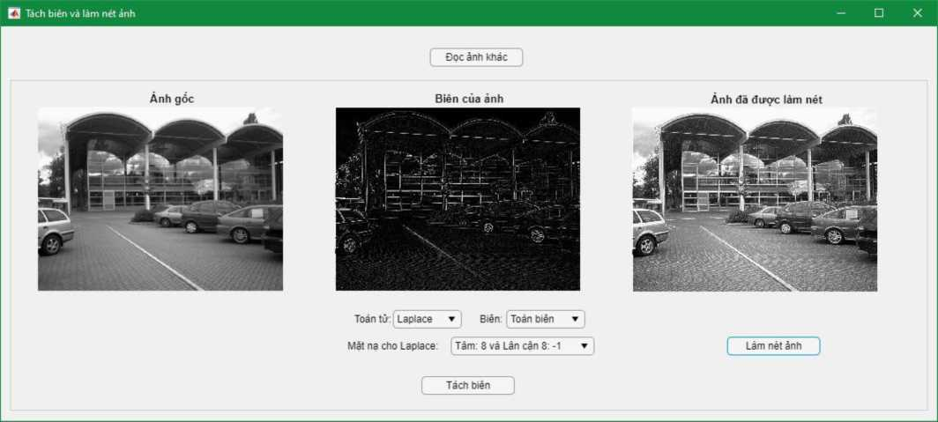

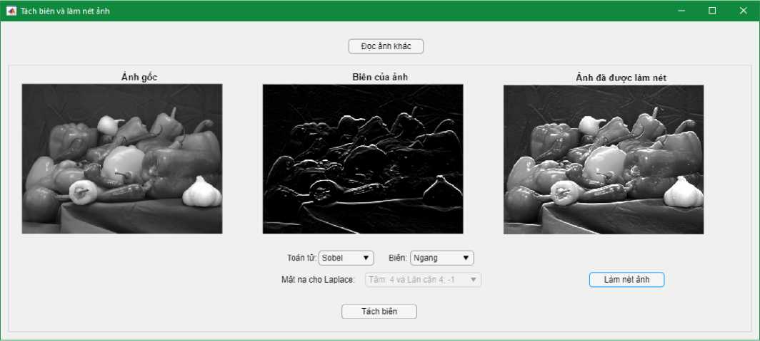

1. X& ly kink tkai

* An mon, lam day anh
* Dong anh, mo anh
* Tuy bien phan tu cau true chu thap hoac hinh vuong.

**Xay dung giao dien;**

* Button: app.btnDocAnh
* Panel app.pnMain:

o Toggle Button Group app.tbg_Phep gom co app.tb AnMon, app.tbLamDay, app.tb Dong, app.tb Mo o Axes: app.axes AnhGoc, app.axes AnhKQ

o Radio Button Group app.rbgPhanTu gom co app.rbVuong, app.rbChuThap o Button: app.btn ThucHien

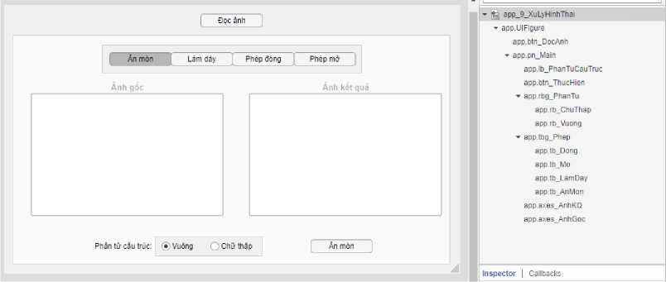

Bo check thuoc tinh Enable cua app.pn_Main de tranh ngndi dung thao tac du lieu rong. Khai bao cac thuoc tinh;

properties (Access = private) img map

**colortype**

**img_kq**

end

**Xay dung chnc nang cho cac thanh phan;**

Button Doc anh - SK: Button Pushed

% Button pushed function: btn DocAnh

function btn DocAnhButtonPushed(app, event)

**[filename, path] = uigetfile({'*.png'; '*.jpg'}, 'Chpn anh'); if ~isequal(filename, 0) && ~isequal(path, 0)**

**app.btn_DocAnh.Text = "Dpc anh khac"; app.pn_Main.Enable = "on";**

**app.tbg_Phep.SelectedObject = app.tb_AnMon;**

**app.btn_ThucHien.Text = "An mon";**

**app.rbg_PhanTu.SelectedObject = app.rb_Vuong;**

**cla(app.axes_AnhKQ);**

**file = strcat(path, filename);**

**[app.img, app.map] = imread(file); app.colortype = imfinfo(file).ColorType; if app.colortype == "truecolor" app.img = rgb2gray(app.img); app.img = imbinarize(app.img);**

**elseif app.colortype == "indexed"**

**app.img = ind2gray(app.img, app.map); app.img = imbinarize(app.img);**

**end**

**imshow(app.img, app.map, 'Parent', app.axes_AnhGoc);**

**end**

end

Button Thuc hien - SK: Button Pushed

% Button pushed function: btn ThucHien

function btn ThucHienButtonPushed(app, event)

**if app.rbg_PhanTu.SelectedObject == app.rb_Vuong ptct = ones(3, 3);**

**else**

**ptct = strel([0, 1, 0; 1, 1, 1; 0, 1, 0]);**

**end**

**if app.tbg_Phep.SelectedObject == app.tb_AnMon app.img_kq = imerode(app.img, ptct); elseif app.tbg_Phep.SelectedObject == app.tb_LamDay app.img_kq = imdilate(app.img, ptct); elseif app.tbg_Phep.SelectedObject == app.tb_Dong app.img_kq = imdilate(app.img, ptct); app.img_kq = imerode(app.img_kq, ptct); elseif app.tbg_Phep.SelectedObject == app.tb_Mo app.img_kq = imerode(app.img, ptct); app.img_kq = imdilate(app.img_kq, ptct);**

**end**

**imshow(app.img_kq, "Parent", app.axes_AnhKQ);**

end

Toggle Button Group Phep xu ly - SK: Selection Changed

% Selection changed function: tbg_Phep

function tbg PhepSelectionChanged(app, event)

**selectedButton = app.tbg_Phep.SelectedObject; if selectedButton == app.tb_AnMon**

**app.btn_ThucHien.Text = "An mon"; elseif selectedButton == app.tb_LamDay app.btn_ThucHien.Text = "Lam day";**

**else**

**app.btn_ThucHien.Text = "Thuc hien";**

**end**

end

**Ket qua:**

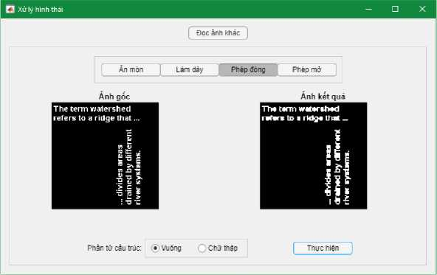

1. Sw dung Components trong Component Library de twang tac tot v&i ngudi dung

**Axes:**

Hien thi anh (goc, xu ly,... ):

imshow(Anh, Map cua anh, "Parent", Axes chua anh);

Hien thi anh phan nguang dan:

imshow(Anh > gia tri pn, Map cua anh, "Parent", Axes chua anh);

Hien thi anh phan nguang kep:

imshow(Anh > gia tri pn trai & Anh < gia tri pn phai, Map cua anh, "Parent",

Axes chua anh);

Hien thi to chuc do:

[numberofpixel, grayscale] = imhist(Anh);

bar(Axes chua to chuc do, grayscale, numberofpixel, 0.5, "stacked", "black");

Su kien Button Down: thuc hien doan lenh da nhap khi ngudi dung nhap chuot vao khu vuc cua Axes.

**Button:** Nut an

Su kien Button Pushed: thuc hien doan lenh da nhap khi ngudi dung an nut xong.

**Check Box:** O danh dau ✓

Su kien Value Changed: thuc hien doan lenh da nhap khi trang thai danh dau bi ngudi dung thay doi (0 ^ □ hoac □ ^ 0).

Drop-down: Danh sach xo

Su kien Value Changed: thuc hien doan lenh da nhap khi ngudi dung chon xong mot doi tuang trong danh sach xo xuong khac voi doi tuang truac da chon.

Su kien Drop-down Opening: thuc hien doan lenh da nhap ngay khi ngudi dung vua xo danh sach. Thudng dung cho viec khdi tao danh sach xo mot cach chu dong trong cua so soan thao lenh. Khdi tao danh sach bang thuoc tinh .Items, vi du:

app.dd PhepToan.Items = ["Cong", "Tru", "Nhan", "Chia"];

**Edit Field (Numeric):** O nhap so

Su kien Value Changed: thuc hien doan lenh da nhap khi ngudi dung thay doi gia tri trong o nhap. (Radio) Button Group: Nhom cac nut lua chon

Su kien Selection Changed: thuc hien doan lenh da nhap khi ngudi dung chon mot Radio Button khac voi Radio Button da chon truac do.

Su kien Button Down: thuc hien doan lenh da nhap khi ngudi dung nhap chuot vao khu vuc cua Button Group.

Slider: Thanh truat chon gia tri

Su kien Value Changing: thuc hien doan lenh da nhap ngay khi ngudi dung con dang keo truat.

Su kien Value Changed: thuc hien doan lenh da nhap khi ngudi dung keo truat xong va tha chuot. Toggle Button Group: Nhom cac nut chuyen doi (tuang tu nhu Radio Button Group)

Su kien Selection Changed: thuc hien doan lenh da nhap khi ngudi dung chon mot Toggle Button khac voi Toggle Button da chon truac do.

Thich hap de thiet lap giao dien chuyen doi cac che do hay chuc nang.

Tai lieu on tap matblat

Doc anh

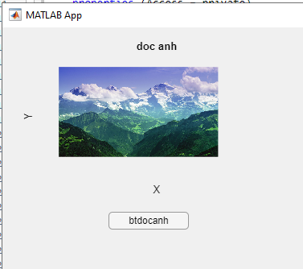

properties (Access = private)

img

map

colortype

end

% Callbacks that handle component events

methods (Access = private)

% Button pushed function: btdocanhButton

function btdocanhButtonPushed(app, event)

[filename, path]=uigetfile({'*.jng';'*.tif';'*jpg'},' Chon anh');

if isequal (filename,0)||isequal(path,0)

uialert(app.UIFigure," chua doc anh"," loi doc anh");

cla(app.UIAxes);

else

file=strcat(path,filename);

app.img=imread (file);

imshow(app.img,'Parent',app.UIAxes)

end

end

end

đoc ảnh , thong tin ảnh,

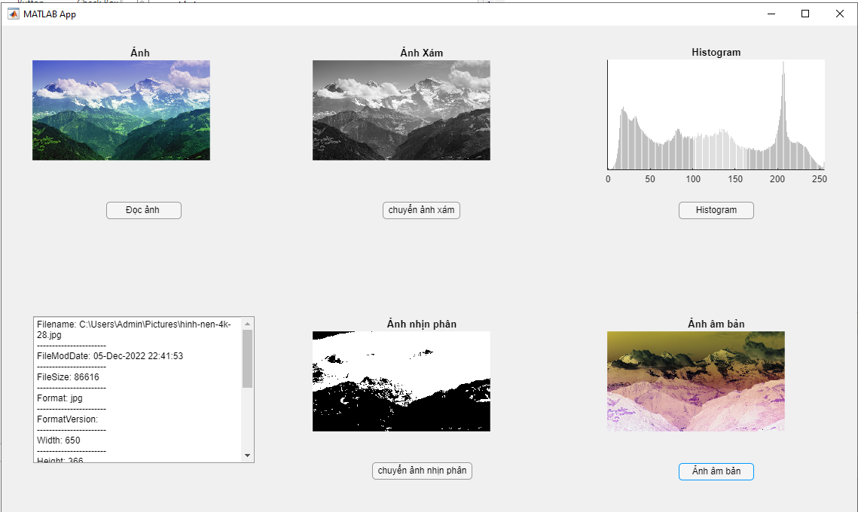

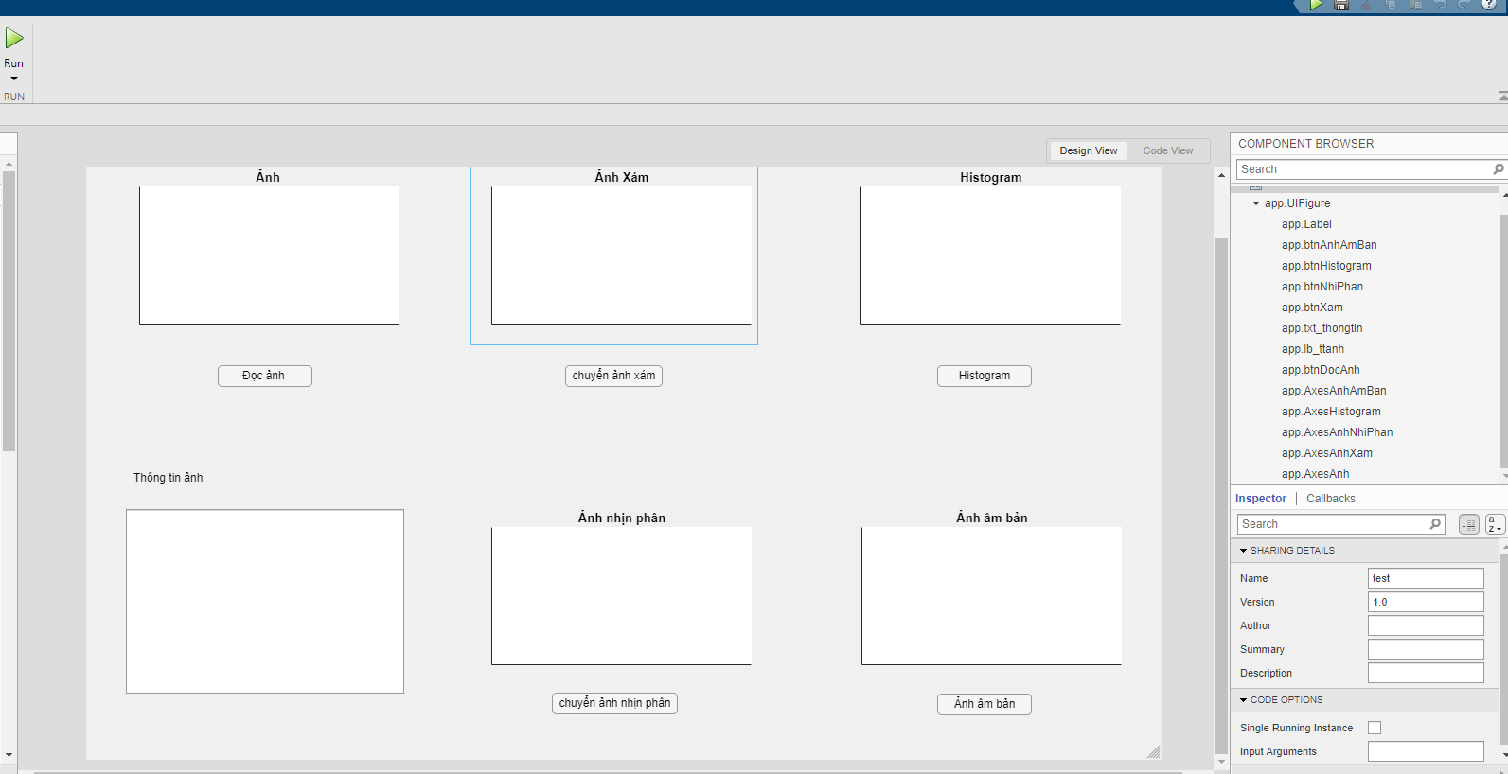

Code:

properties (Access = private)

Property % Description

img

colortype

end

% Callbacks that handle component events

methods (Access = private)

doc ảnh và thong tin ảnh

% Button pushed function: btnDocAnh

function btnDocAnhPushed(app, event)

f=app.UIFigure;

[filename,path]=uigetfile({'*.png';'*.jpg';'*.tif'},'Chon anh');

if isequal(filename, 0) || isequal(path,0)

uialert(f,'Chua chon anh','Loi doc anh');

cla(f);

else

file=strcat(path,filename);

[app.img]=imread(file);

imshow(app.img , 'parent', app.AxesAnh);

info=imfinfo(file);

arr=[];

if length(info)>1

app.lb_ttanh.Text=strcat(strcat("Tập tin chứa: ", num2str(length(info)))," ảnh");

arr=[arr,"THONG TIN ANH DAU TIEN"];

info=info(1);

else

app.lb_ttanh.Text="";

end

app.colortype=info.ColorType;

fields=fieldnames(info);

for i=1:length(fields)

if isnumeric(info.(char(fields(i))))

value=num2str(info.(char(fields(i))));

else

value = info.(char(fields(i)));

end

str=strcat(fields(i),": ",value);

arr=[arr;str];

arr=[arr;'-----------------------'];

end

app.txt_thongtin.Value=arr;

end

end

button ảnh xám

% Button pushed function: btnXam

function btnXamButtonPushed(app, event)

if app.colortype=="truecolor"

rgb=app.img;

gray=rgb2gray(rgb);

imshow(gray,'Parent',app.AxesAnhXam);

elseif app.colortype=="indexed"

ind=app.img;

gray=ind2gray(ind,app.map);

imshow(gray,'Parent',app.AxesAnhXam);

else

imshow(app.img,'Parent',app.AxesAnhXam);

end

end

button ảnh nhị phân

% Button pushed function: btnNhiPhan

function btnNhiPhanButtonPushed(app, event)

if app.colortype=="truecolor"

rgb=app.img;

gray=rgb2gray(rgb);

bw=imbinarize(gray);

imshow(bw,'Parent',app.AxesAnhNhiPhan);

elseif app.colortype=="indexed"

ind=app.img;

gray=ind2gray(ind,app.map);

bw=imbinarize(gray);

imshow(bw,'Parent',app.AxesAnhNhiPhan);

else

bw=imbinarize(app.img);

imshow(bw,'Parent',app.AxesAnhNhiPhan);

end

end

btt ảnh histogram

% Button pushed function: btnHistogram

function btnHistogramButtonPushed(app, event)

[pixels,graylevers]=imhist(app.img);

bar(app.AxesHistogram,graylevers,pixels,0.2,"stacked","black");

end

% Callback function

function btnTruotButtonPushed(app, event)

end

btton am bản

% Button pushed function: btnAnhAmBan

function btnAnhAmBanButtonPushed(app, event)

app.img = imcomplement(app.img);

imshow(app.img,'Parent',app.AxesAnhAmBan);

end

btton to chuc đồ

% Callback function

function btnToChucDoButtonPushed(app, event)

function [oimg,omap] = truot_histogram (file,c)

[img,map]=imread(file);

info=imfinfo(file);

if length (info)>1

info=info(1);

end

lmax=2^info.BitDepth-1;

[y1,x1]=size(img);

oimg=zeros(y1,x1);

omap=map;

for i=1:y1

for j=1:x1

oimg(i,j)= img(i,j)+c;

if oimg(i,j)>lmax

oimg(i,j)=lmax;

end

if oimg(i,j)<0

oimg(i,j)=0;

end

end

end

end

if app.DropDownTCD.Value=="Trượt tổ chức đồ"

c=app.Slider.Value;

[im,m] = truot_histogram(app.file,c)

imshow(im,m,'parent',app.AxesToChucDo);

end

function [oimg,omap] = cang_histogram (file,c)

[img,map]=imread(file);

info=imfinfo(file);

if length (info)>1

info=info(1);

end

lmax=2^info.BitDepth-1;

[y1,x1]=size(img);

oimg=zeros(y1,x1);

omap=map;

for i=1:y1

for j=1:x1

oimg(i,j)= round(img(i,j)*c);

[im,m] = cang_histogram(app.file,c)

if oimg(i,j)>lmax

oimg(i,j)=lmax;

end

end

end

end

if app.DropDownTCD.Value=="Căng tổ chức đồ"

c=app.Slider.Value;

[im,m] = cang_histogram(app.file,c)

imshow(im,m,'parent',app.AxesToChucDo);

end

ảnh trược và ảnh trươt his

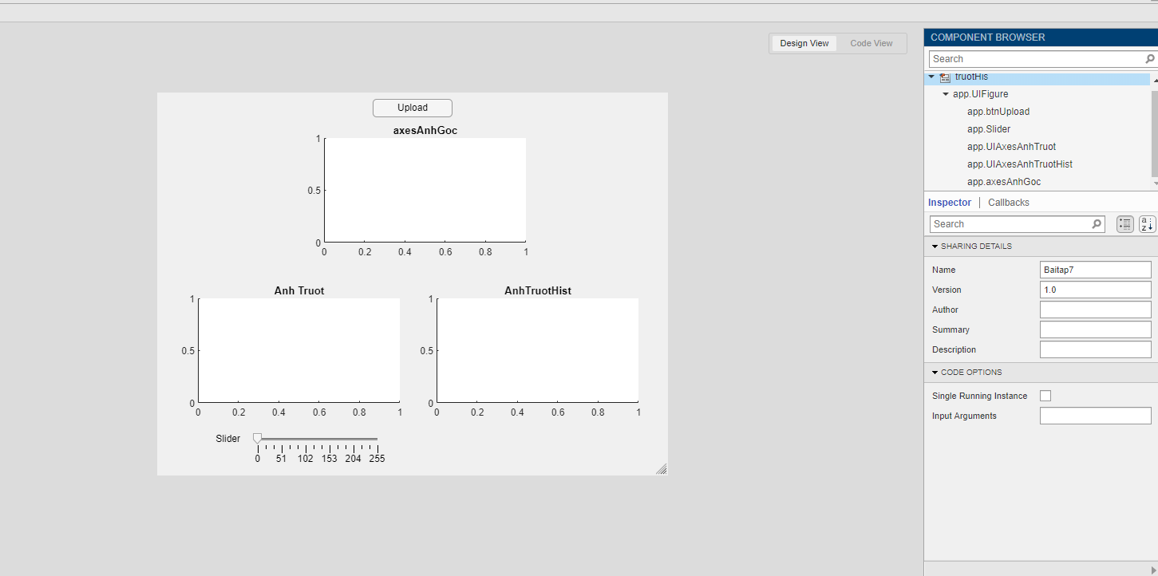

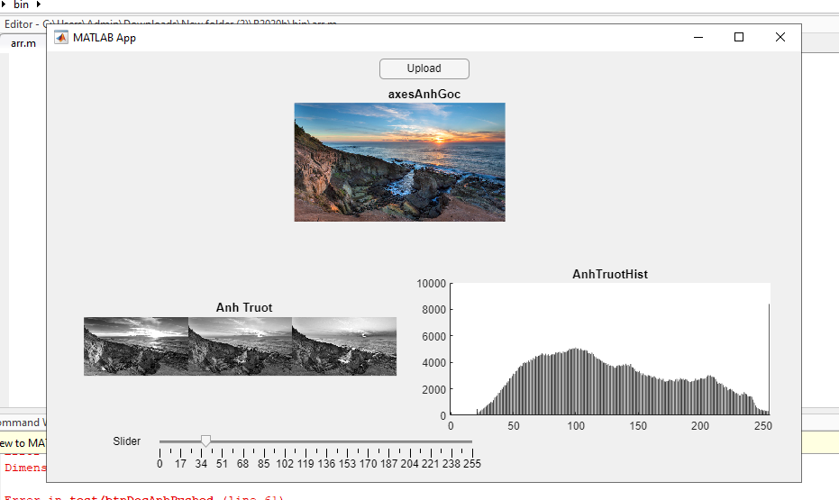

**code**

properties (Access = private)

img

bitdepth

map

end

methods (Access = private)

function oimg = truotToChucDo(app)

[y,x]=size(app.img);

oimg=zeros(y,x);

c=app.Slider.Value;

Lmax=2^app.bitdepth-1;

for i=1:y

for j=1:x

oimg(i,j)=app.img(i,j)+c;

if(oimg(i,j)>Lmax)

oimg(i,j)=Lmax;

end

end

end

end

end

% Callbacks that handle component events

methods (Access = private)

% Button pushed function: btnUpload

function btnUploadButtonPushed(app, event)

f=app.UIFigure;

[filename,path]=uigetfile({'*.png';'*.jpg';'*.tif'},'Chon anh');

if isequal(filename, 0) || isequal(path,0)

figure(f);

uialert(f,'Chua chon anh','Loi doc anh');

else

figure(f);

file=strcat(path, filename);

app.img = imread(file);

imshow(app.img, 'Parent', app.axesAnhGoc);

info = imfinfo(file);

app.bitdepth = info.BitDepth;

end

end

% Value changing function: Slider

function SliderValueChanging(app, event)

oimg=app.truotToChucDo;

imshow(oimg,[],'Parent',app.UIAxesAnhTruot);

[onumberofpixel, ograyscale]=imhist(uint8(oimg));

bar(app.UIAxesAnhTruotHist, ograyscale,onumberofpixel,0.5,"stacked","black");

end

căng tô chuc đồ;

+Căng: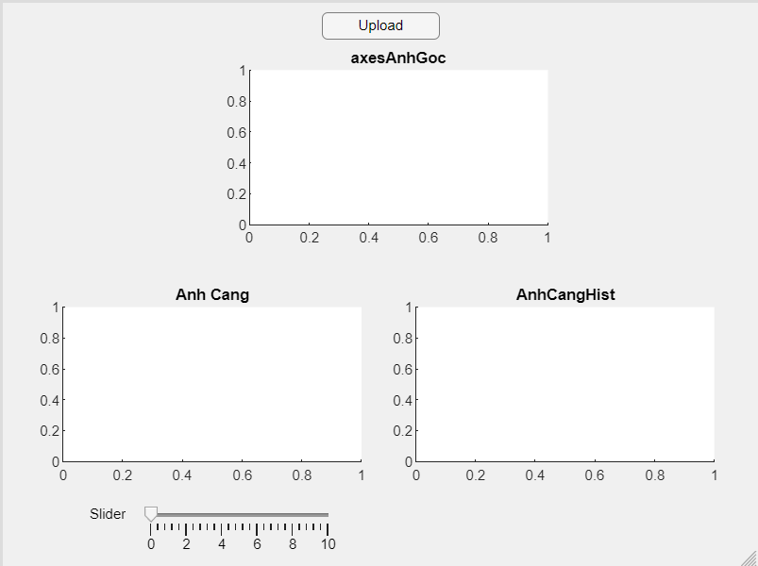

*Phải đọc ảnh vào:

**Properties :**

img

bitdepth

map

methods (Access = private)

function oimg = cangToChucDo(app)

[y,x]=size(app.img);

oimg=zeros(y,x);

c=app.Slider.Value;

Lmax=2^app.bitdepth-1;

for i=1:y

for j=1:x

oimg(i,j)= round(app.img(i,j)*c);

if oimg(i,j)>Lmax

oimg(i,j)=Lmax;

end

end

end

end

end

**Code:**

Callback Upload: ( chuột phải nút -> chọn Callback -> Go to ... )

f=app.UIFigure;

[filename,path]=uigetfile({'*.png';'*.jpg';'*.tif'},' Chon anh');

if isequal(filename, 0) || isequal(path,0)

figure(f);

uialert(f,'Chua chon anh','Loi doc anh');

else

figure(f);

file=strcat(path, filename);

app.img = imread(file);

imshow(app.img, 'Parent', app.axesAnhGoc);

info = imfinfo(file);

app.bitdepth = info.BitDepth;

end

Callback Slider: ( chuột phải nút -> chọn Callback -> Go to ... )

oimg=app.cangToChucDo;

imshow(oimg,[],'Parent',app.UIAxesAnhCang);

[onumberofpixel, ograyscale]=imhist(uint8(oimg));

bar(app.UIAxesAnhCangHist, ograyscale,onumberofpixel,0.5,"stacked","black");

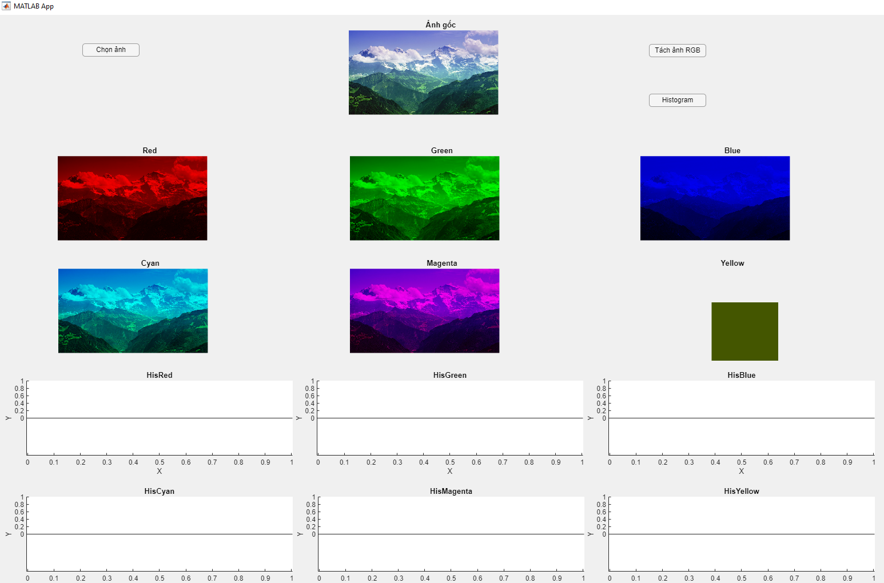

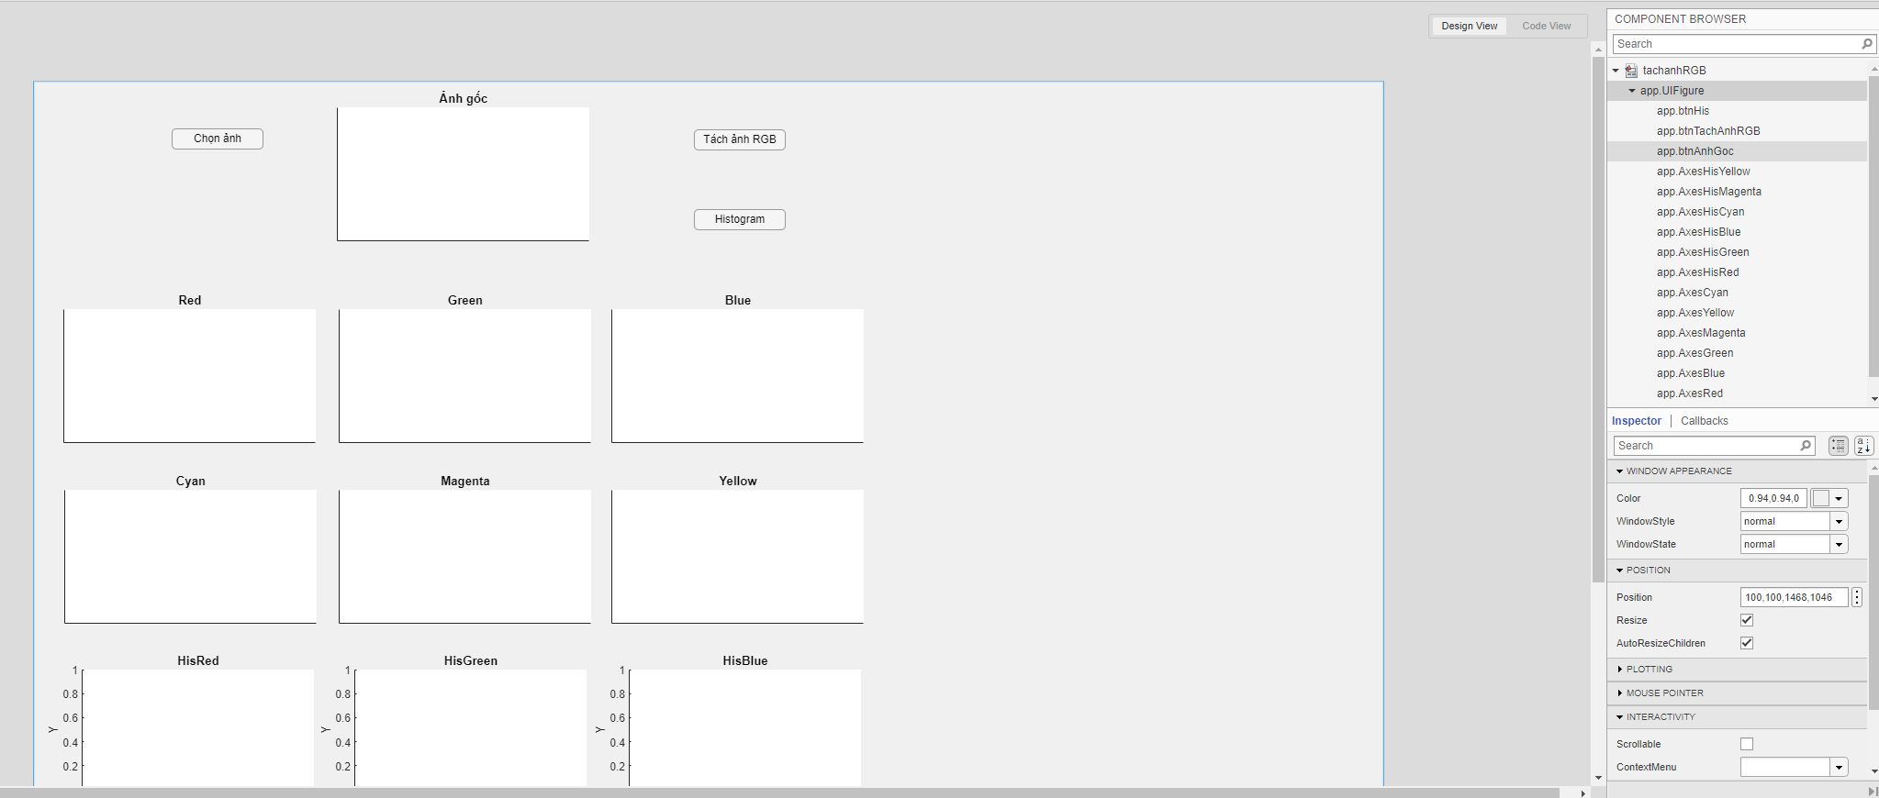

Code:

properties (Access = private)

Property % Description

img

colortype

map

red

green

blue

cyan

magenta

yellow

end

% Callbacks that handle component events

methods (Access = private)

% Button pushed function: btnAnhGoc

function btnAnhGocButtonPushed(app, event)

f=app.UIFigure;

[filename,path]=uigetfile('*','Chon anh');

if isequal(filename, 0) || isequal(path,0)

uialert(f,'Chua chon anh','Loi doc anh');

cla(app.AxesAnhGoc);

else

file=strcat(path,filename);

[app.img,app.map]=imread(file);

info=imfinfo(file);

app.colortype=info.ColorType;

if app.colortype~="truecolor"

uialert(f,'Phai chon anh RGB','Loi chon anh');

cla(app.AxesAnhGoc);

else

imshow(app.img,app.map, 'parent', app.AxesAnhGoc);

end

end

end

% Button pushed function: btnTachAnhRGB

function btnTachAnhRGBButtonPushed(app, event)

app.red=app.img;

app.red(:,:,2)=0;

app.red(:,:,3)=0;

app.green=app.img;

app.green(:,:,1)=0;

app.green(:,:,3)=0;

app.blue=app.img;

app.blue(:,:,1)=0;

app.blue(:,:,2)=0;

imshow(app.red,'Parent',app.AxesRed);

imshow(app.green,'Parent',app.AxesGreen);

imshow(app.blue,'Parent',app.AxesBlue);

app.cyan=app.img;

app.cyan(:,:,1)=0;

app.magenta=app.img;

app.magenta(:,:,2)=0;

app.yellow=app.img;

app.yellow(:,:,3)=0;

imshow(app.cyan,'Parent',app.AxesCyan);

imshow(app.magenta,'Parent',app.AxesMagenta);

imshow(app.yellow,'Parent',app.AxesYellow);

end

% Button pushed function: btnHis

function btnHisButtonPushed(app, event)

[pixels,graylevers]=imhist(app.red);

bar(app.AxesHisRed,graylevers,pixels,0.9,"stacked","red");

[pixels,graylevers]=imhist(app.green);

bar(app.AxesHisGreen,graylevers,pixels,0.9,"stacked","green");

[pixels,graylevers]=imhist(app.blue);

bar(app.AxesHisBlue,graylevers,pixels,0.9,"stacked","blue");

[pixels,graylevers]=imhist(app.cyan);

bar(app.AxesHisCyan,graylevers,pixels,0.9,"stacked","cyan");

[pixels,graylevers]=imhist(app.magenta);

bar(app.AxesHisMagenta,graylevers,pixels,0.9,"stacked","magenta");

[pixels,graylevers]=imhist(app.yellow);

bar(app.AxesHisYellow,graylevers,pixels,0.9,"stacked","yellow");

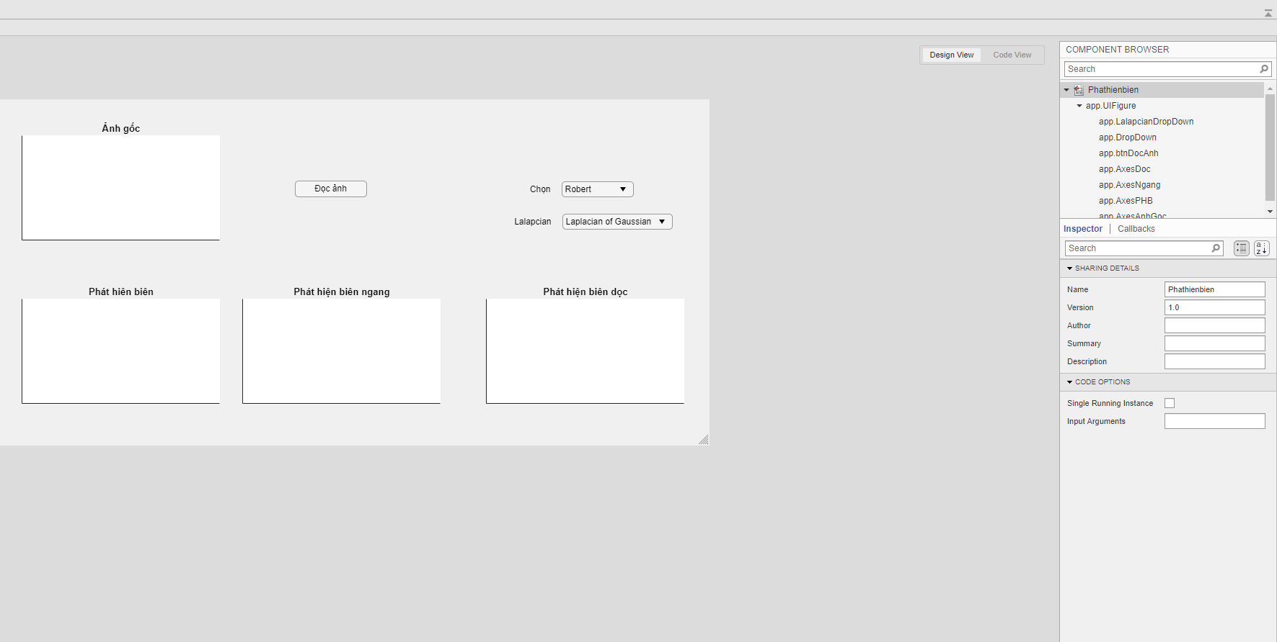

code:

properties (Access = private)

Property % Description

img

colortype

map

end

% Callbacks that handle component events

methods (Access = private)

% Button pushed function: btnDocAnh

function btnDocAnhButtonPushed(app, event)

f=app.UIFigure;

[filename,path]=uigetfile({'*.png';'*.jpg';'*.tif'},'Chon anh');

if isequal(filename, 0) || isequal(path,0)

uialert(f,'Chua chon anh','Loi doc anh');

cla(f);

else

file=strcat(path,filename);

[app.img]=imread(file);

imshow(app.img , 'parent', app.AxesAnhGoc);

end

end

% Callback function

function DropDownClicked(app, event)

item = app.DropDown.Value

if item=="Robert"

ro_x=[1 0 ; 0 -1];

gx=filter2(ro_x, app.img);

imshow(gx/255,'Parent',app.AxesNgang);

ro_y =[0 1 ; -1 0] ;

gy=filter2(ro_y,app.img);

imshow(gy/255,'Parent',app.AxesDoc);

kq=sqrt(gx.^2 + gy.^2);

imshow(kq/255,'Parent',app.AxesPHB)

end

if item=="Prewitt"

pr_x=[-1 0 1; -1 0 1; -1 0 1];

gx=filter2(pr_x, app.img);

imshow(gx/255,'Parent',app.AxesDoc);

pr_y =[-1 -1 -1; 0 0 0; 1 1 1] ;

gy=filter2(pr_y,app.img);

imshow(gy/255,'Parent',app.AxesNgang);

kq=sqrt(gx.^2 + gy.^2);

imshow(kq/255,'Parent',app.AxesPHB)

end

if item=="Sobel"

so_x=[-1 0 1; -2 0 2; -1 0 1];

gx=filter2(so_x, app.img);

imshow(gx/255,'Parent',app.AxesDoc);

so_y =[-1 -2 -1; 0 0 0; 1 2 1] ;

gy=filter2(so_y,app.img);

imshow(gy/255,'Parent',app.AxesNgang);

kq=sqrt(gx.^2 + gy.^2);

imshow(kq/255,'Parent',app.AxesPHB)

end

phan đoạn dưa trên cường độ

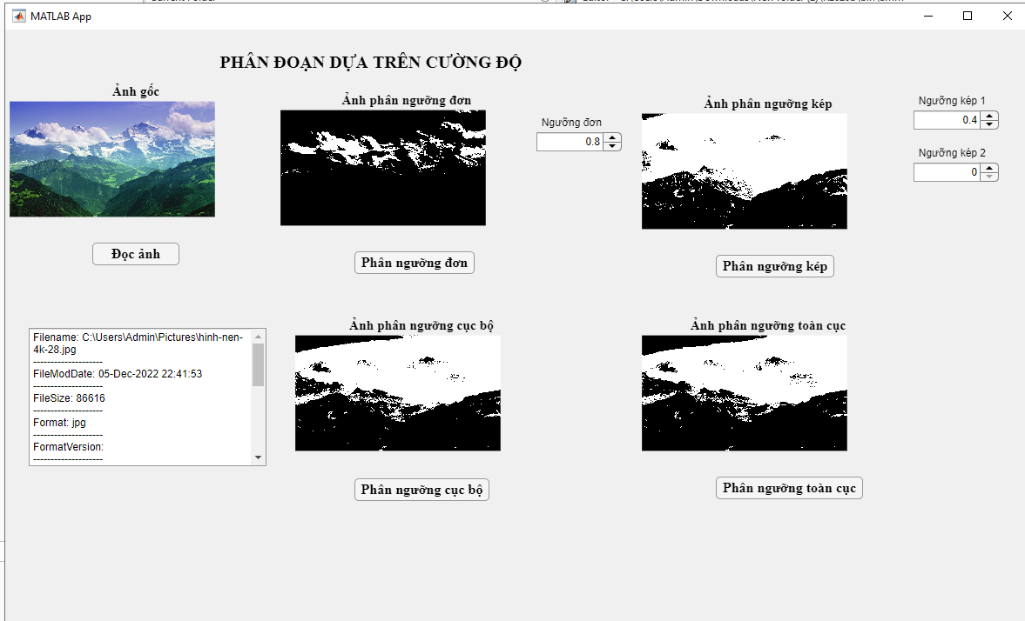

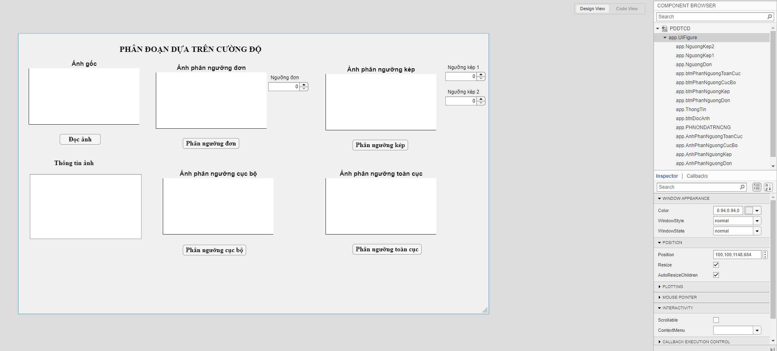

Code

properties (Access = private)

img

map

colortype

end

% Callbacks that handle component events

methods (Access = private)

% Button pushed function: btnDocAnh

function btnDocAnhButtonPushed(app, event)

f=app.UIFigure;

[filename,path]=uigetfile({'*.png';'*.jpg';'*.tif'},'Chọn ảnh');

if isequal(filename,0)||isequal(path,0)

uialert(f,'Chưa chọn ảnh','Lỗi đọc ảnh');

cla(app.AnhGoc);

else

file=strcat(path,filename);

[app.img,app.map]=imread(file);

imshow(app.img,app.map,'Parent',app.AnhGoc);

info=imfinfo(file);

arr=[];

if length(info)>1

app.ThngtinnhLabel.Text=strcat(strcat("Tập tin chứa: ",num2str(length(info)))," ảnh");

arr=[arr;"THÔNG TIN ẢNH ĐẦU TIÊN"];

info=info(1);

else

app.ThngtinnhLabel.Text="";

end

app.colortype=info.ColorType;

fields=fieldnames(info);

for i=1:length(fields)

if isnumeric(info.(char(fields(i))))

value=num2str(info.(char(fields(i))));

else

value=info.(char(fields(i)));

end

str=strcat(fields(i),": ",value);

arr=[arr;str];

arr=[arr;'--------------------'];

end

app.ThongTin.Value=arr;

end

end

% Button pushed function: btnPhanNguongDon

function btnPhanNguongDonButtonPushed(app, event)

imshow(im2bw(app.img,app.NguongDon.Value),'Parent',app.AnhPhanNguongDon);

end

% Button pushed function: btnPhanNguongKep

function btnPhanNguongKepButtonPushed(app, event)

imshow(im2bw(app.img,app.NguongKep1.Value)&im2bw(app.img,app.NguongKep2.Value),'Parent',app.AnhPhanNguongKep);

end

% Button pushed function: btnPhanNguongCucBo

function btnPhanNguongCucBoButtonPushed(app, event)

imshow(im2bw(app.img,graythresh(app.img)),'Parent',app.AnhPhanNguongCucBo);

end

% Button pushed function: btnPhanNguongToanCuc

function btnPhanNguongToanCucButtonPushed(app, event)

id=im2double(app.img);

t=0.5*(min(id(:))+max(id(:)));

deltaT=0.01;

done=false;

while done

g=id>=t;

tnext=0.5*(mean(id(g))+mean(id( g)));

done=abs(t-tnext)<deltaT;

t=tnext;

end

imshow(im2bw(app.img,t),'Parent',app.AnhPhanNguongToanCuc);

end